**Stack:**

**Introduction**:

Stacks are used in scenarios where one needs to implement LIFO (last in fist in) policy. Java generic LinkedList class which comes as part of collections framework can used to implement a stack. LinkedList class extends from List class and implements collections class. It provides in-built functions for push, pop, peek etc stack operations.

**Problem:**

A medical store supplies drug X. Consumers prefer to always buy the batch of drug X with longest expiration date into the future. This means consumers prefer to buy drug X from a bath which arrived most recently in store. For example in month of July, consumers will prefer to bug drug X arrived in a batch of June over a batch which arrived in January. Due to various economic factors and government policy changes, selling price of drug X that medical store charged kept varying over a year time frame. Let’s say selling price of drug X changes every month over a year. Every month store gets only one batch of drug X. Every batch of drug X contains 1000 tablets. Every month consumers purchase somewhere between 850 to 1250 tablets in total. When current month’s batch runs out store start selling from previous month’s batch. And when that runs out previous to previous batch is used. This behavior can be captured by a stack which dynamically grows and reduces in size every month. If store totally runs out of drug X at any point (bottom of stack is hit) and still have consumers asking for it, that’s a loss of business and manager keep count of how many time this happened over the year. Model this using a stack and show how stack varies over the year. Use that to calculate final revenue over the year by selling the drug. Use junit to verify.

**Code:**

import java.util.Arrays;  
import java.util.LinkedList;  
import java.util.Random;  
  
class PerMonthTrade {  
 int remainingTablets;  
 int numTabletsSold;  
  
 PerMonthTrade(){  
 remainingTablets = 1000;  
 numTabletsSold = 0;  
 }  
}

import org.junit.*;  
import java.util.Arrays;  
import java.util.LinkedList;  
import java.util.Random;  
  
public class StackTest {  
 @Test  
 public void myTest() {  
  
 Random rand = new Random();  
  
 //Array containing number of tablets consumers asked for every month  
 //Every index of array is a month  
 int demandEachMonth[] = new int[12];  
 System.*out*.println(demandEachMonth.length);  
  
 for (int i = 0; i < demandEachMonth.length; i++)  
 demandEachMonth[i] = rand.nextInt(401) + 850; // Generates random number between 850 and 1250 inclusive.  
  
 System.*out*.println(Arrays.*toString*(demandEachMonth));  
 //Array containing selling price per tablet each month  
 int sellingPriceEachMonth[] = {12,15,11,9,17,13,18,10,9,12,17,11};  
  
 LinkedList<PerMonthTrade> monthlyInventory = new LinkedList<>();  
 int supplyShortage[] = new int[12];  
 int TabletsSoldEachMonth[] = new int[12];  
 boolean done;  
 int total_revenue = 0;  
  
 for (int i = 0; i < 12; i++) {// Loop per month of year.  
  
 //First add new month's supply into stack  
 monthlyInventory.addFirst(new PerMonthTrade());  
  
 System.*out*.println("BEGINNING Month : " + i + " Demand = " + demandEachMonth[i]);  
 TabletsSoldEachMonth[i] = demandEachMonth[i];  
 int j = 0;  
 for (PerMonthTrade p : monthlyInventory) {  
 System.*out*.println("Printing StackID: " + j++ + " Remaining Tablets: " + p.remainingTablets);  
 }  
 //Check if monthly demand is met by supply otherwise pop monthlyInventory stack and use from previous month  
 //If bottom of stack is hit count supply shortage in that month.  
 done = false;  
  
 if (demandEachMonth[i] <= monthlyInventory.getFirst().remainingTablets) {  
 monthlyInventory.getFirst().remainingTablets -= demandEachMonth[i];  
 demandEachMonth[i] = 0;  
  
 Assert.*assertTrue*(monthlyInventory.size() > 0);  
  
 } else {  
 demandEachMonth[i] -= monthlyInventory.getFirst().remainingTablets;  
 monthlyInventory.removeFirst(); //pop first element  
 while (monthlyInventory.size() > 0) {  
  
 Assert.*assertTrue*(monthlyInventory.size() > 0);  
  
 if (demandEachMonth[i] <= monthlyInventory.getFirst().remainingTablets) {  
 monthlyInventory.getFirst().remainingTablets -= demandEachMonth[i];  
 done = true;  
 demandEachMonth[i] = 0;  
 break;  
 } else {  
 demandEachMonth[i] -= monthlyInventory.getFirst().remainingTablets;  
 monthlyInventory.removeFirst();  
 }  
 }  
 //Keep account of number of tablets sold per month.  
 if(!done && (monthlyInventory.size() == 0)) {  
 supplyShortage[i] = demandEachMonth[i];  
 TabletsSoldEachMonth[i] -= supplyShortage[i];  
 }  
  
 }  
 Assert.*assertTrue*((demandEachMonth[i] == 0) || (demandEachMonth[i] == supplyShortage[i]));  
  
 total_revenue += TabletsSoldEachMonth[i]*sellingPriceEachMonth[i];  
  
 System.*out*.println("\nEND Month : " + i + " Demand Unmet = " + demandEachMonth[i]);  
 j = 0;  
 for (PerMonthTrade p : monthlyInventory) {  
 System.*out*.println("Printing StackID: " + j++ + " Remaining Tablets: " + p.remainingTablets);  
 }  
 System.*out*.println("\n");  
  
 }  
  
 System.*out*.println("TOTAL REVENUE SELLING DRUG: "+total_revenue);  
  
 }  
  
  
  
}

**Results:** 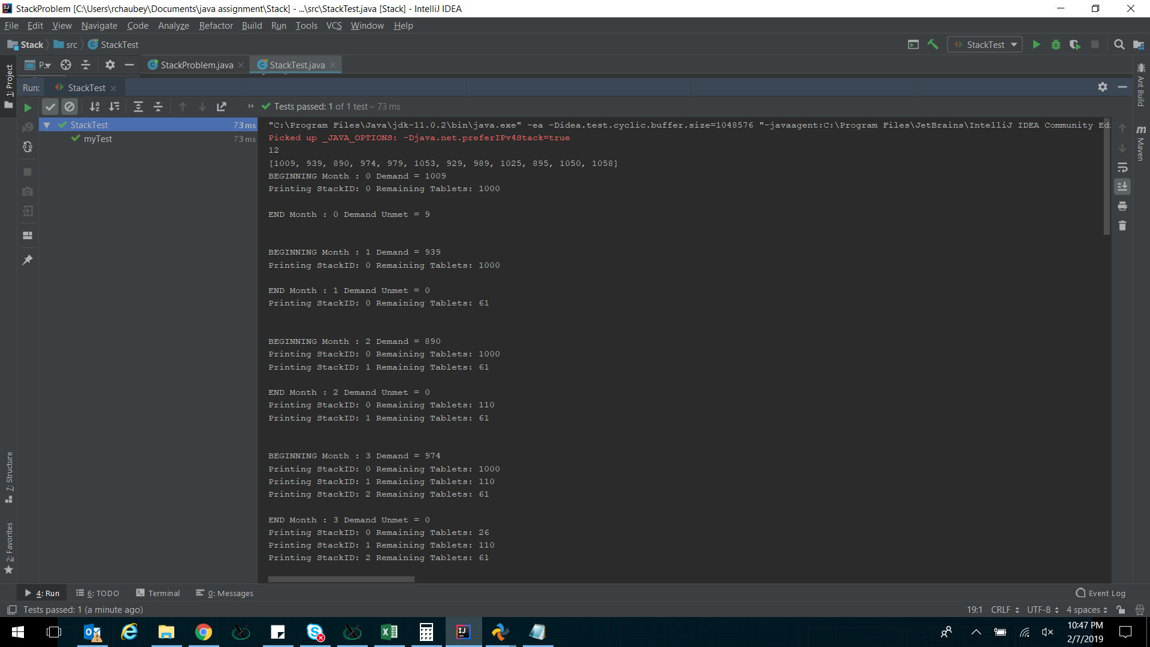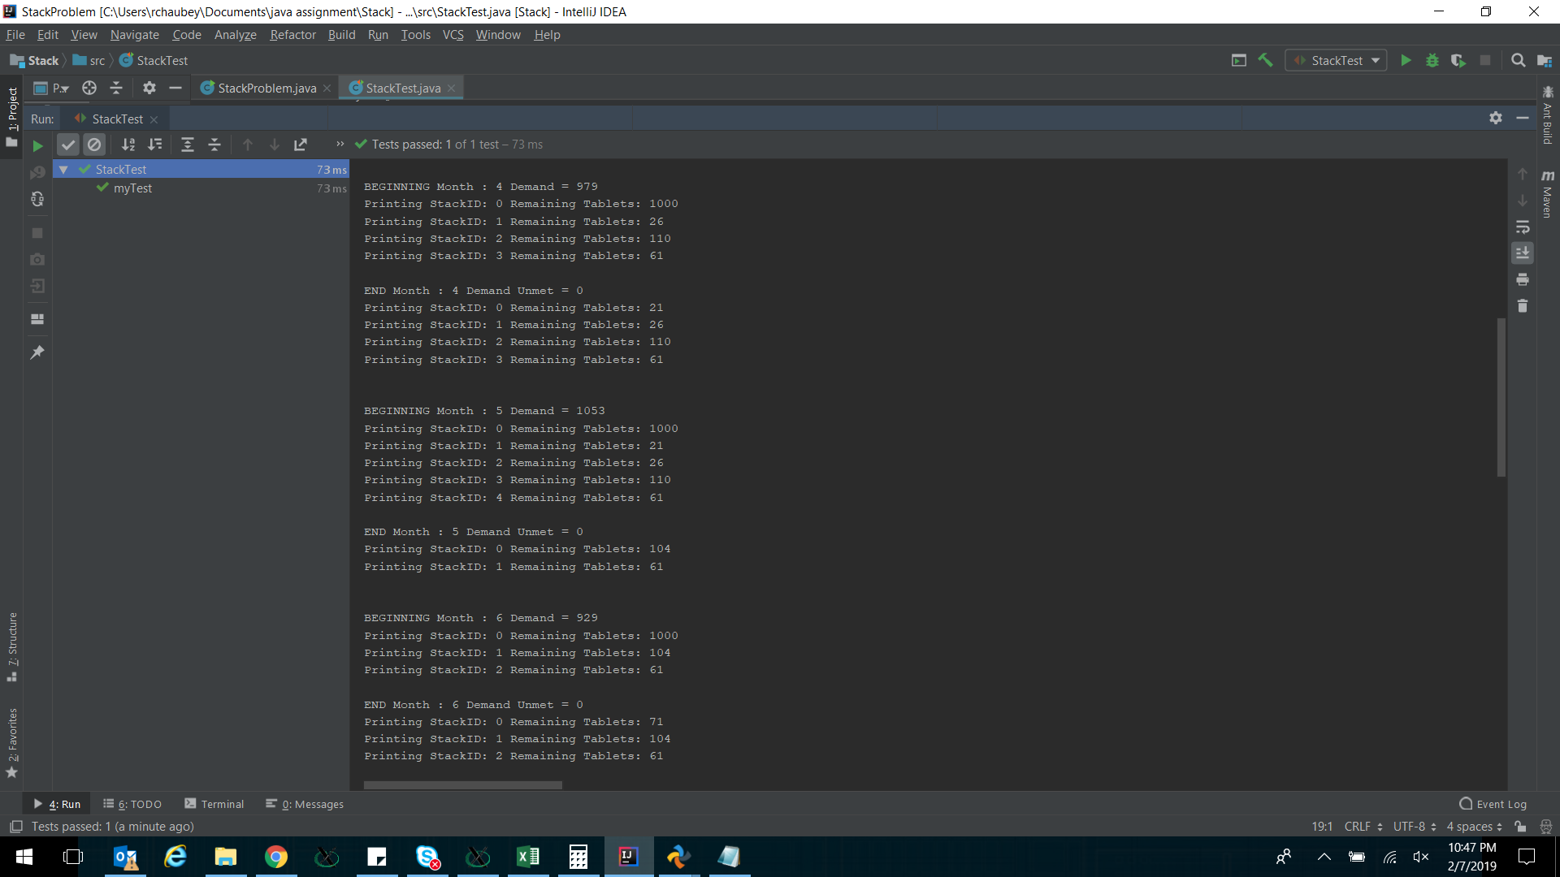

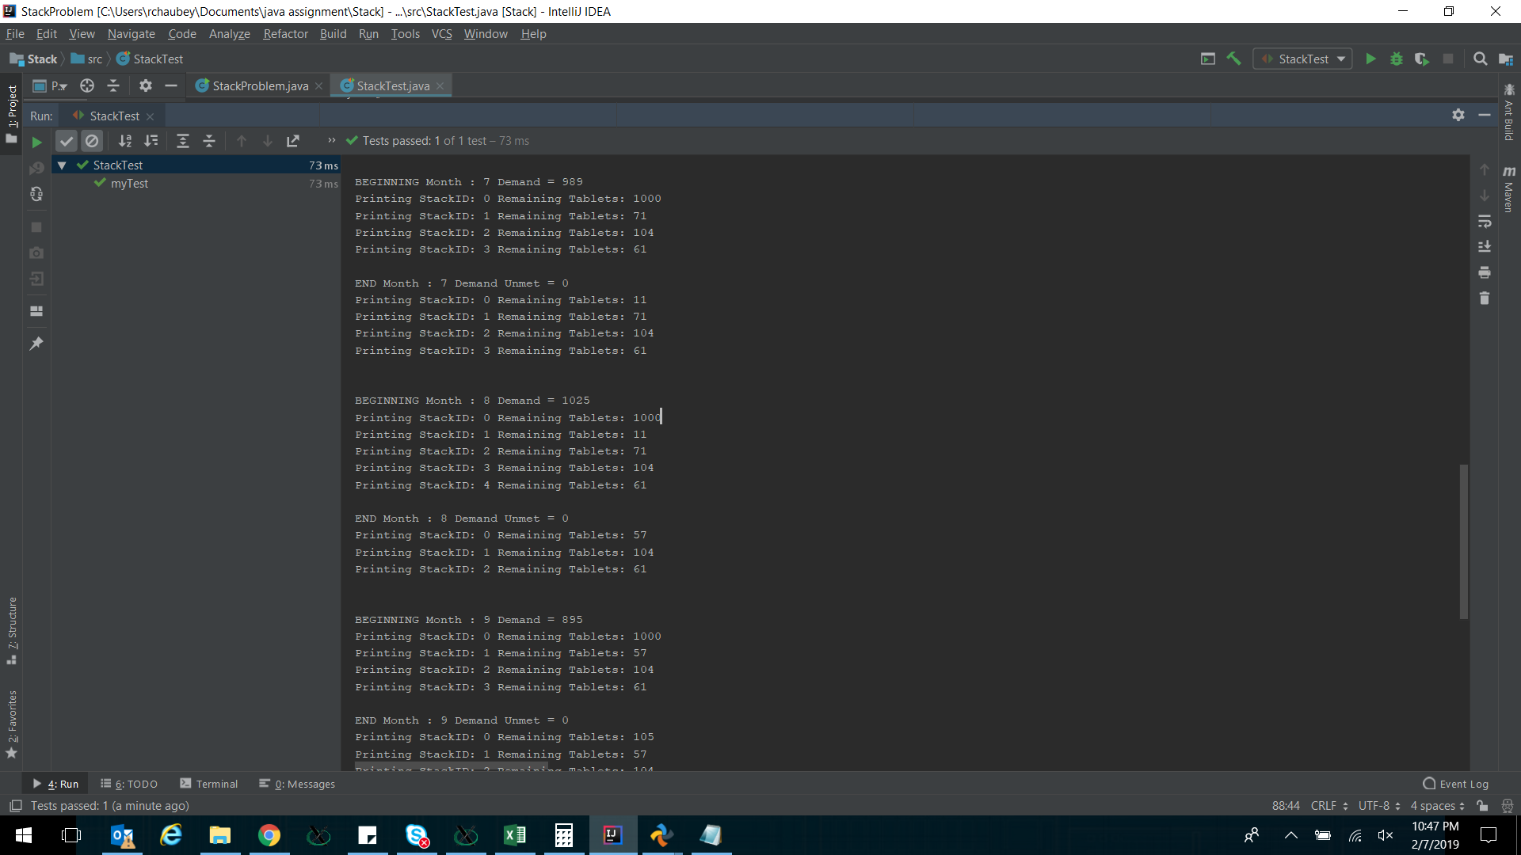

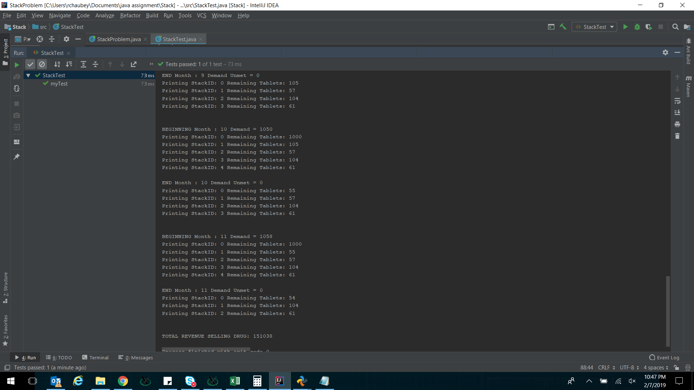

**Queue:**

**Introduction:**

Queues are used to implement FIFO (first in first out) policy. LinkedList which comes as part of Java collections framework can be used to implement a queue. It provided in-built add, remove queue functions.

**Problem:**

Following problem I created based upon a real life scenario where queues are required to be used to maintain FIFO policy.

Air traffic controller’s flight queue modelling. An airport has 4 runways from where planes can take off. Flights are queued into these four runway queue as soon as a slot becomes available. Every runway queue can hold maximum of 4 aircrafts. Every once in a while few flights get canceled and needs to be deallocated from the queue and new flights are given their places. Let’s assume every hour 20 new flights become available for take-off and added to a master queue. From master queue we move the flights to runway queues. Model this air traffic control pattern in java program, do random cancellations of flights on the fly and maintain FIFO order in runway queues. Use junit to verify.

**Code:**

import java.util.LinkedList;  
import java.util.Random;  
  
class AirTrafficController {  
  
  
 // Master Queue // Every hour 20 new flights are added into this.  
 // Flights are indentified by their int flight numbers which are between 100 and 999  
 LinkedList<Integer> masterQueue = new LinkedList<>();  
 //Runway queues  
 LinkedList<Integer> runwayQueue1 = new LinkedList<>();  
 LinkedList<Integer> runwayQueue2 = new LinkedList<>();  
 LinkedList<Integer> runwayQueue3 = new LinkedList<>();  
 LinkedList<Integer> runwayQueue4 = new LinkedList<>();  
  
 void AddNewFlights() {  
 Random rand = new Random();  
 int flightnum;  
 for (int i = 0; i < 20; i++) {  
 flightnum = rand.nextInt(900) + 100;  
 masterQueue.addFirst(flightnum);  
 }  
 }  
  
 void ArbitrateRunWays() {  
 while (masterQueue.size() > 0) {  
 if (runwayQueue1.size() < 5) {  
 runwayQueue1.addFirst(masterQueue.getLast());  
 masterQueue.removeLast();  
 }  
 if (runwayQueue2.size() < 5) {  
 runwayQueue2.addFirst(masterQueue.getLast());  
 masterQueue.removeLast();  
 }  
 if (runwayQueue3.size() < 5) {  
 runwayQueue3.addFirst(masterQueue.getLast());  
 masterQueue.removeLast();  
 }  
 if (runwayQueue4.size() < 5) {  
 runwayQueue4.addFirst(masterQueue.getLast());  
 masterQueue.removeLast();  
 }  
 if (runwayQueue1.size() == 4 && runwayQueue2.size() == 4 && runwayQueue3.size() == 4 && runwayQueue4.size() == 4)  
 break;  
 }  
  
 }  
  
 void FlightsTakeOff() {  
 while (runwayQueue1.size() > 0) {  
 System.*out*.println("Flight Number: " + runwayQueue1.getLast() + " taking off from runway1 ");  
 runwayQueue1.removeLast();  
 }  
 while (runwayQueue2.size() > 0) {  
 System.*out*.println("Flight Number: " + runwayQueue2.getLast() + " taking off from runway2 ");  
 runwayQueue2.removeLast();  
 }  
 while (runwayQueue3.size() > 0) {  
 System.*out*.println("Flight Number: " + runwayQueue3.getLast() + " taking off from runway3 ");  
 runwayQueue3.removeLast();  
 }  
 while (runwayQueue4.size() > 0) {  
 System.*out*.println("Flight Number: " + runwayQueue4.getLast() + " taking off from runway4 ");  
 runwayQueue4.removeLast();  
 }  
  
 }  
 void RandomFlightCancellations() {  
 Random rand = new Random();  
 //Pick a runway randomly  
 int runway = rand.nextInt(3) + 1;  
  
 //Pick a flight randomly  
 int runway_size;  
 if(runway == 1) runway_size = runwayQueue1.size();  
 else if(runway == 2) runway_size = runwayQueue2.size();  
 else if(runway == 3) runway_size = runwayQueue3.size();  
 else runway_size = runwayQueue4.size();  
 int index = rand.nextInt(runway_size);  
  
 //Remove cancelled flight from runway queue  
 if(runway == 1 && runwayQueue1.size() > 0) {  
 System.*out*.println("Canceled Runway 1 Flight Number: " + runwayQueue1.get(index));  
 runwayQueue1.remove(index);  
 }  
 else if(runway == 2 && runwayQueue2.size() > 0) {  
 System.*out*.println("Canceled Runway 2 Flight Number: " + runwayQueue2.get(index));  
 runwayQueue2.remove(index);  
 }  
 else if(runway == 3 && runwayQueue3.size() > 0) {  
 System.*out*.println("Canceled Runway 3 Flight Number: " + runwayQueue3.get(index));  
 runwayQueue3.remove(index);  
 }  
 else if(runway == 4 && runwayQueue4.size() > 0) {  
 System.*out*.println("Canceled Runway 4 Flight Number: " + runwayQueue4.get(index));  
 runwayQueue4.remove(index);  
 }  
 }  
  
 void PrintQqeueSizes() {  
 System.*out*.println("\nMASTER Queue Size: " + masterQueue.size());  
 System.*out*.println("RunWay 1 Queue Size: " + runwayQueue1.size());  
 System.*out*.println("RunWay 2 Queue Size: " + runwayQueue2.size());  
 System.*out*.println("RunWay 3 Queue Size: " + runwayQueue3.size());  
 System.*out*.println("RunWay 4 Queue Size: " + runwayQueue4.size() +"\n");  
  
 }  
  
}

import org.junit.*;  
import java.util.Random;  
  
public class QueueTest {  
 @Test  
 public void myTest() {  
 AirTrafficController ats = new AirTrafficController();  
 Random rand = new Random();  
 int numOfCancelledFlights;  
 for (int i = 0; i < 24; i++) {  
 numOfCancelledFlights = rand.nextInt(4); //Randomly cancel few flights.  
 ats.AddNewFlights();  
 ats.ArbitrateRunWays();  
 for (int j = 0; j < numOfCancelledFlights; j++) ats.RandomFlightCancellations();  
 Assert.*assertTrue*(ats.masterQueue.size() > 0);  
 Assert.*assertTrue*(ats.runwayQueue1.size() < 5);  
 Assert.*assertTrue*(ats.runwayQueue2.size() < 5);  
 Assert.*assertTrue*(ats.runwayQueue3.size() < 5);  
 Assert.*assertTrue*(ats.runwayQueue4.size() < 5);  
  
 ats.PrintQqeueSizes();  
 ats.FlightsTakeOff();  
  
 }  
  
 }  
}

**Results:**

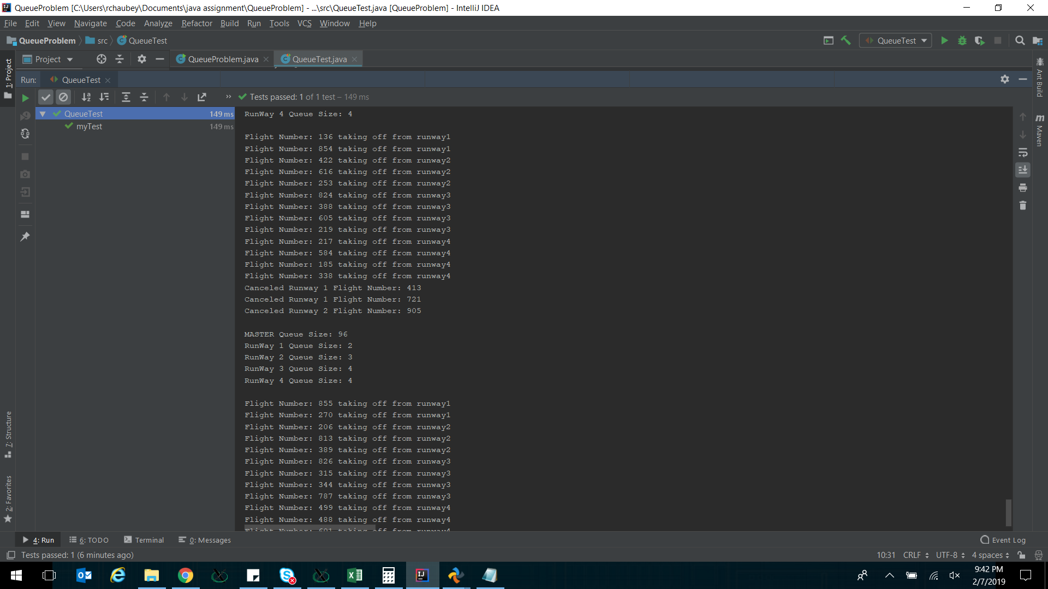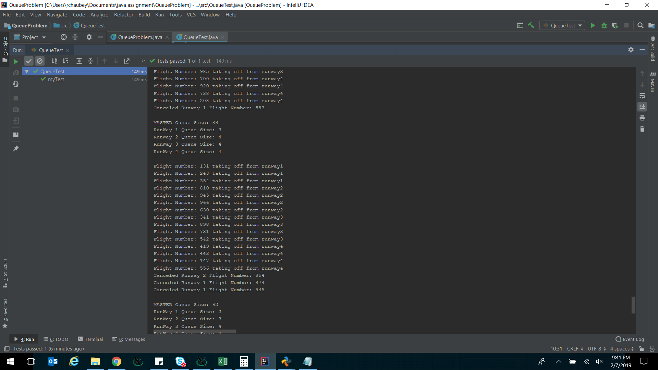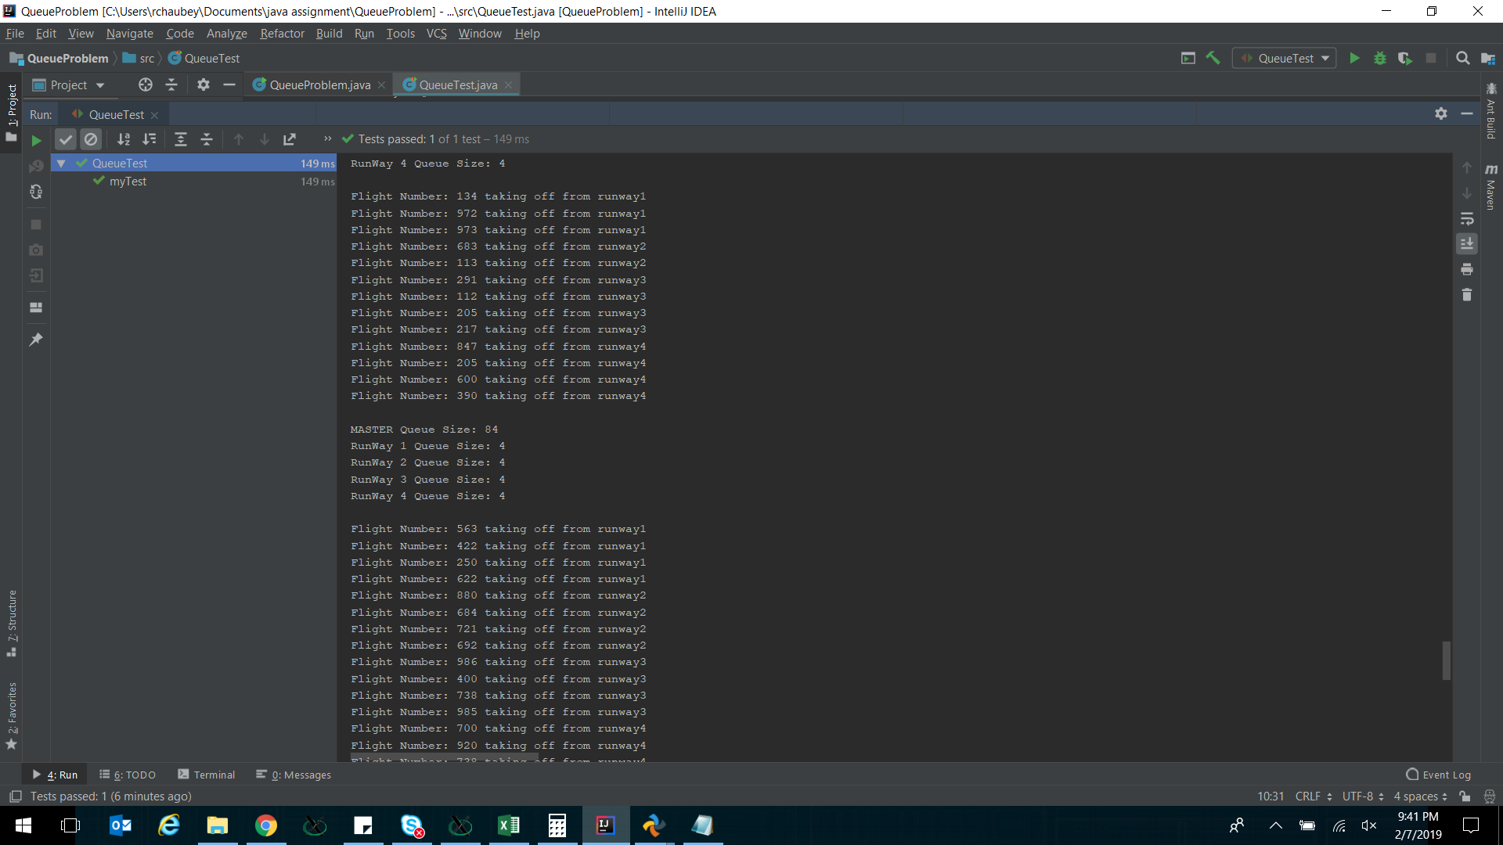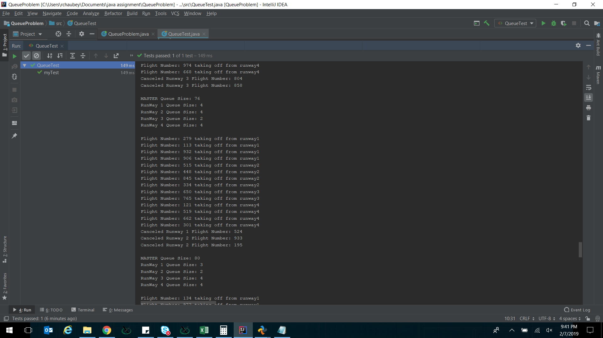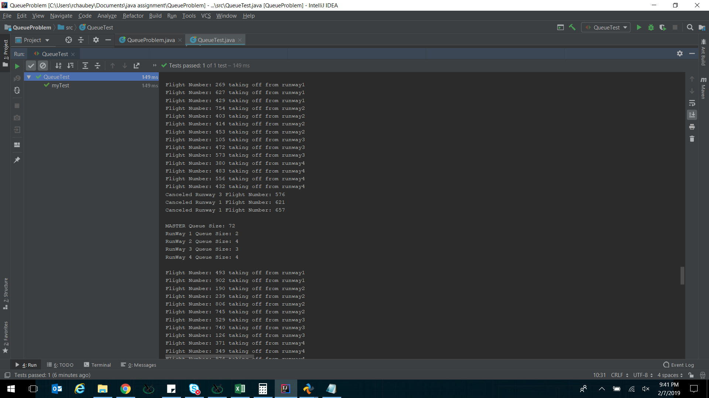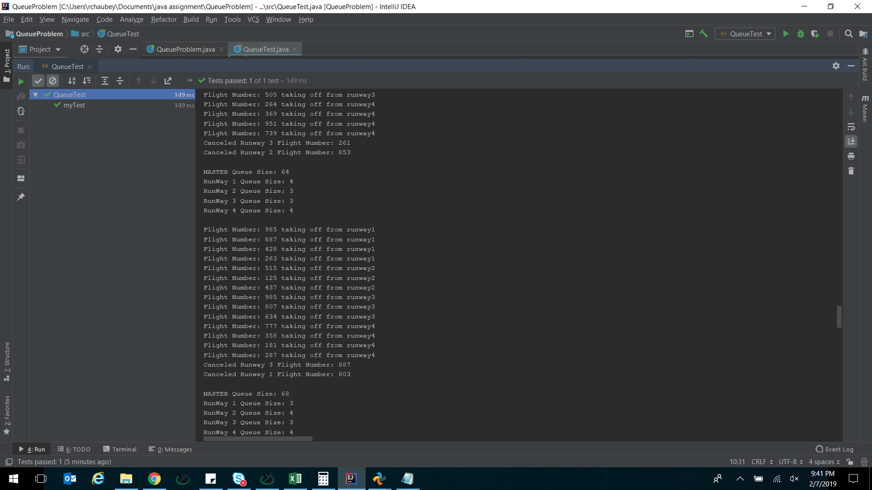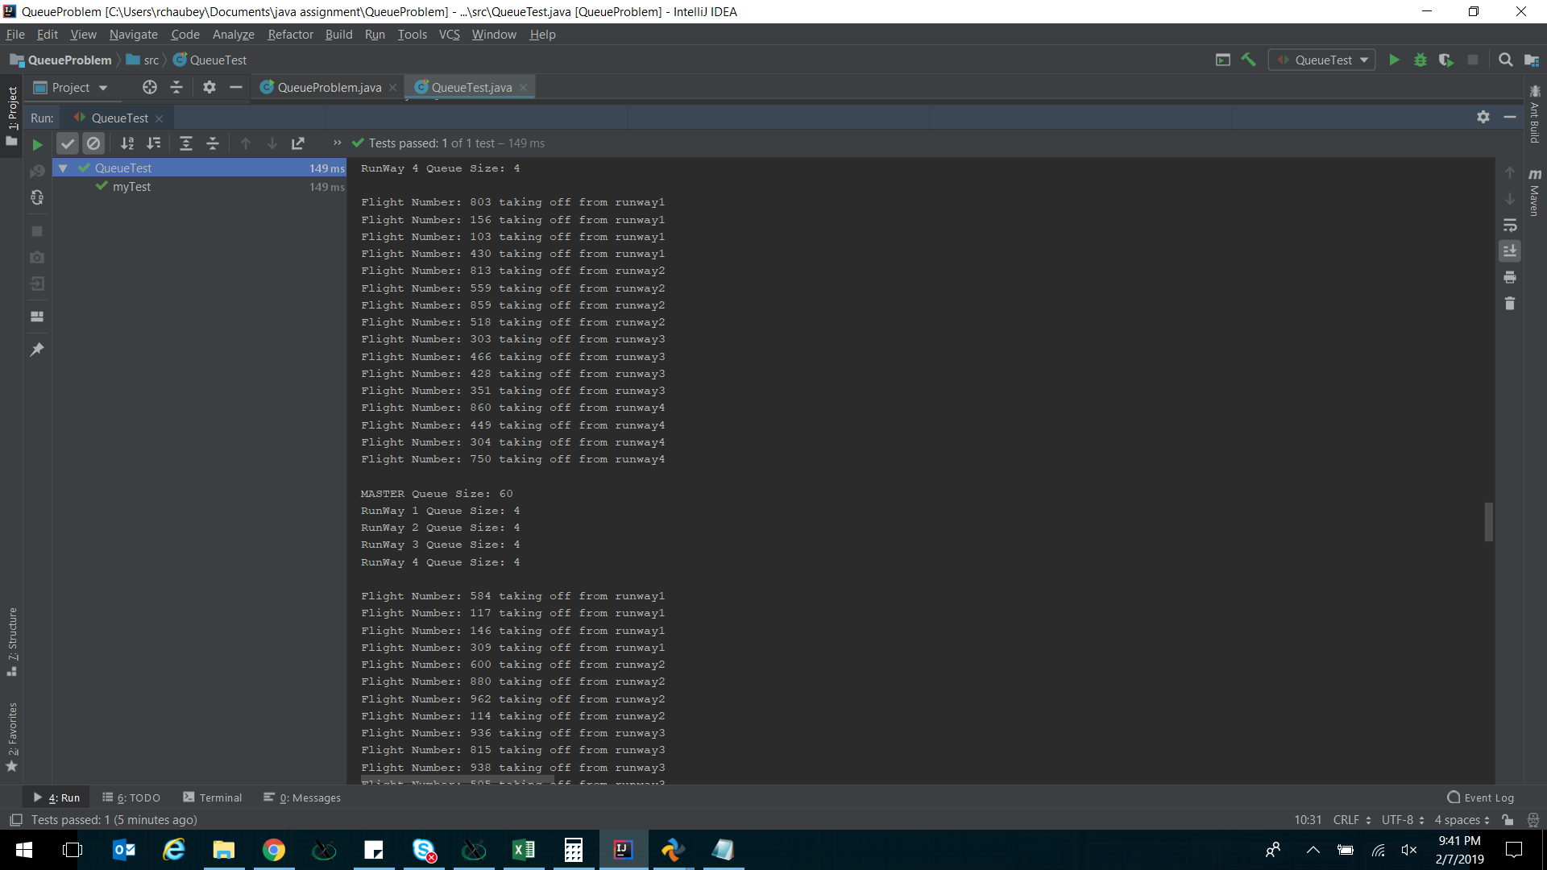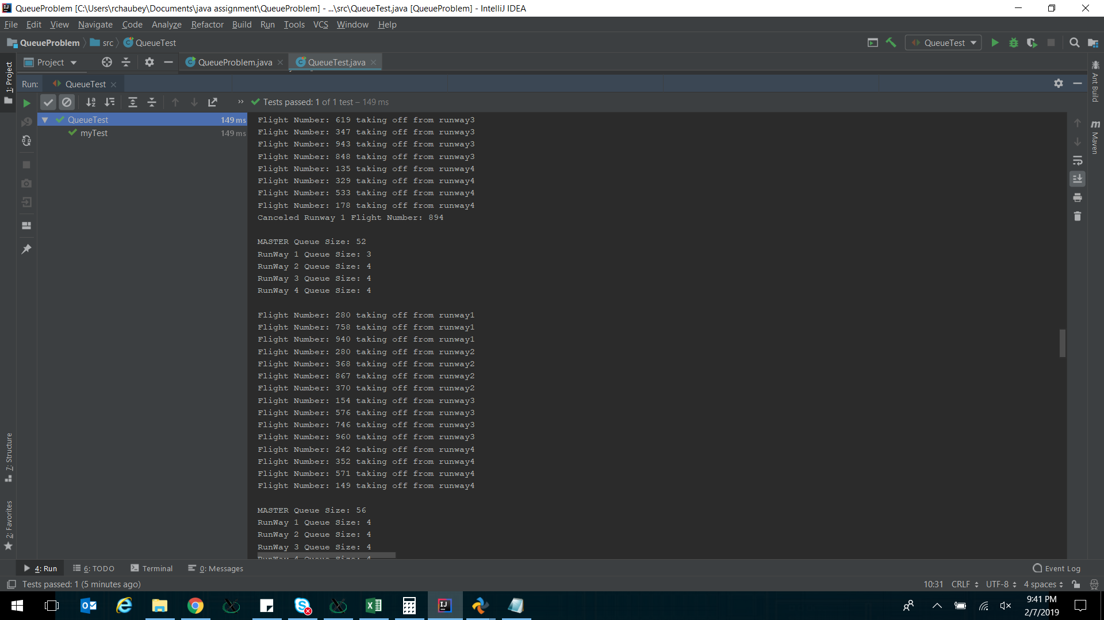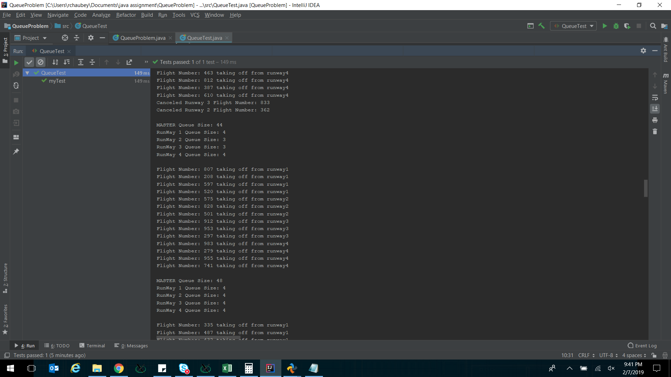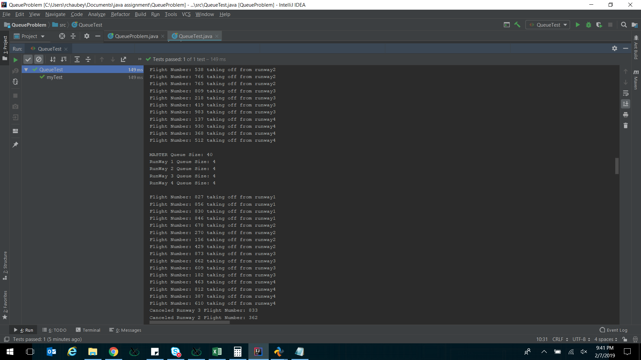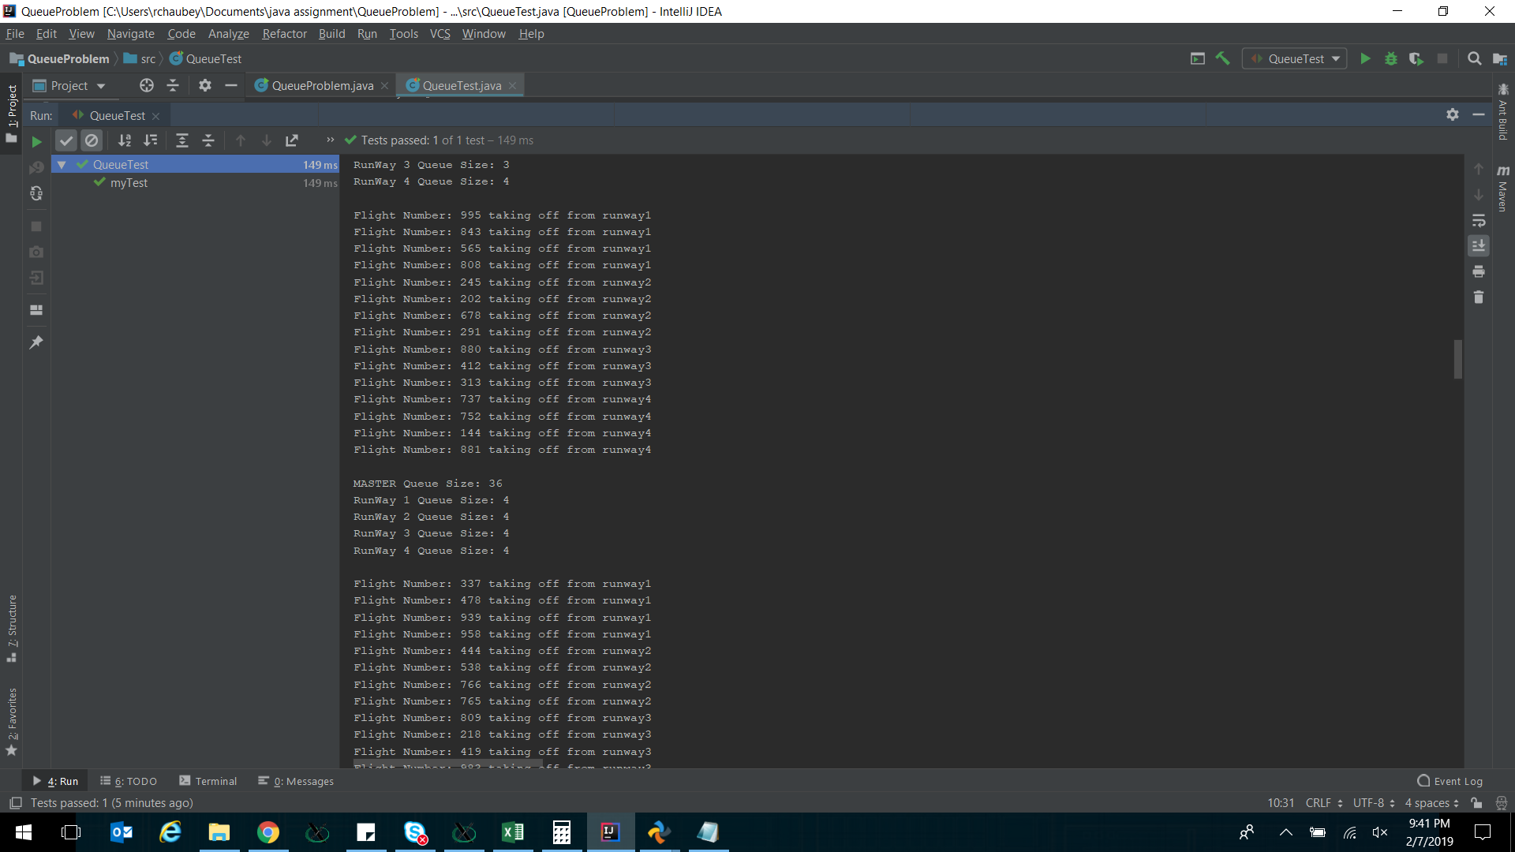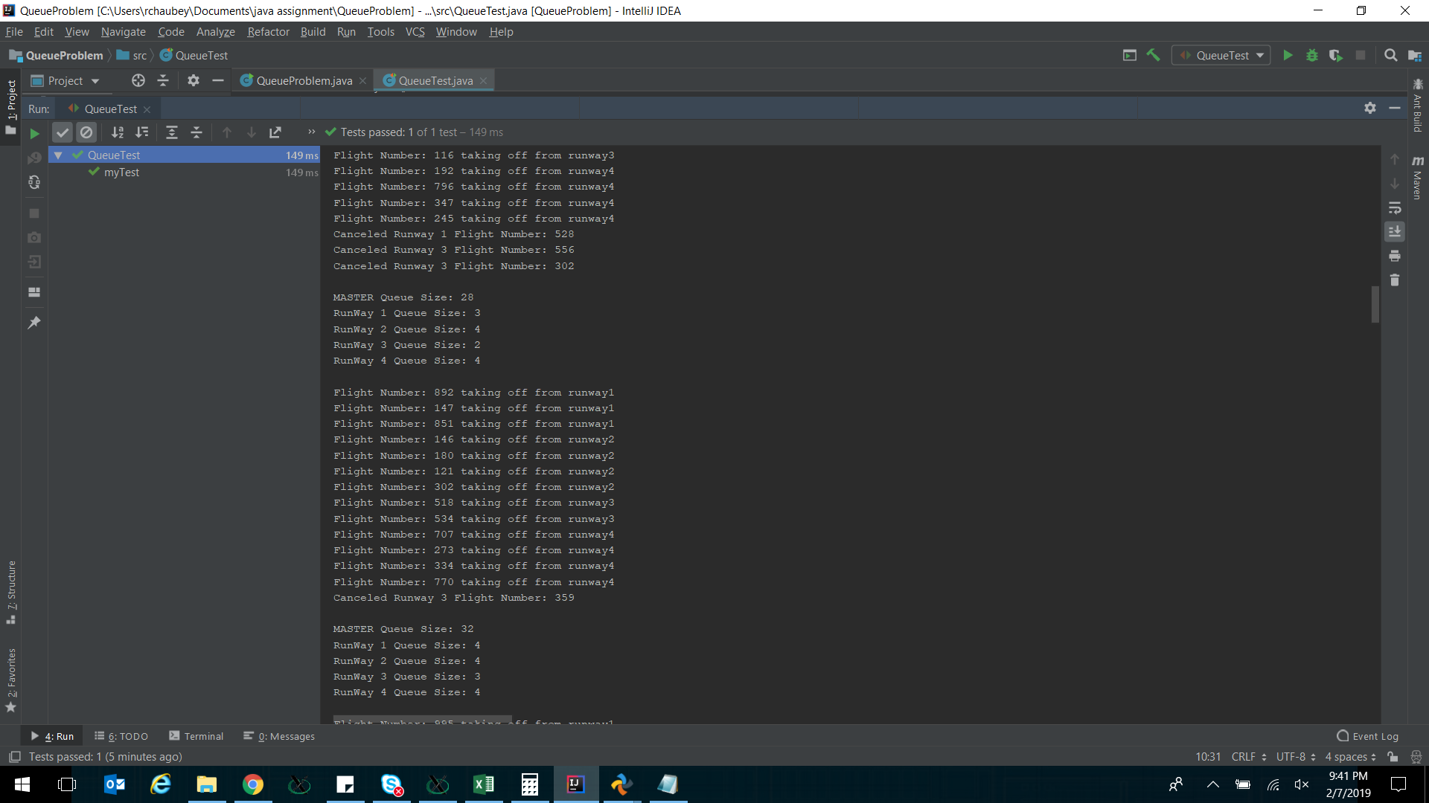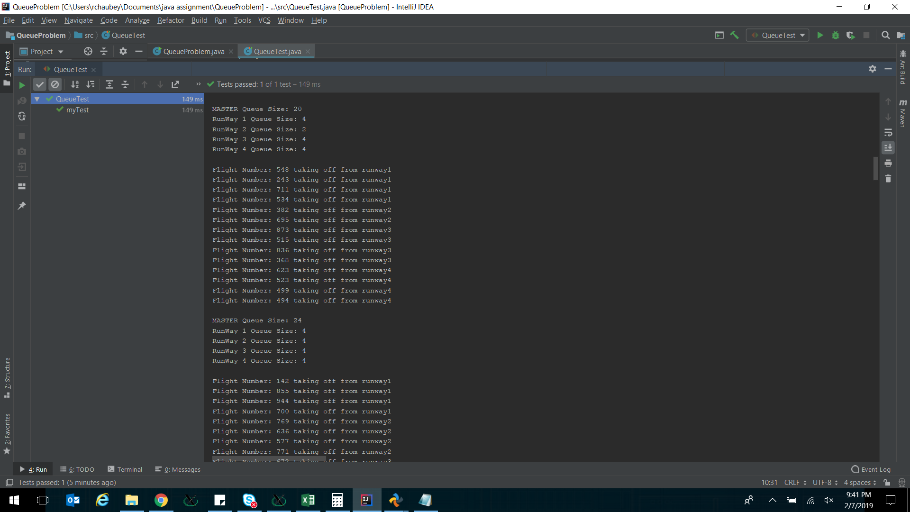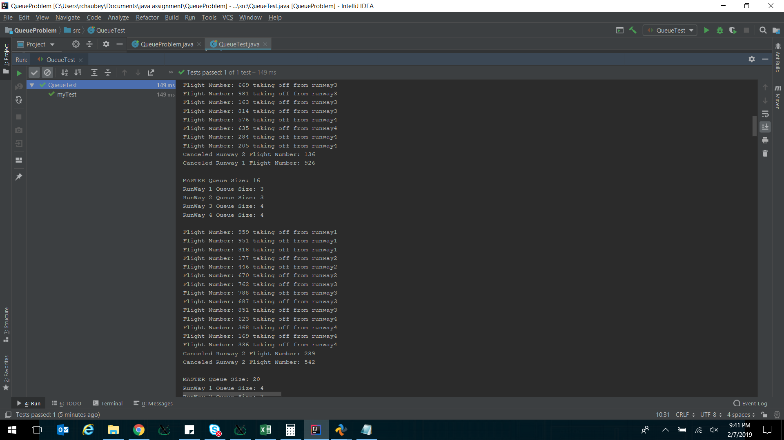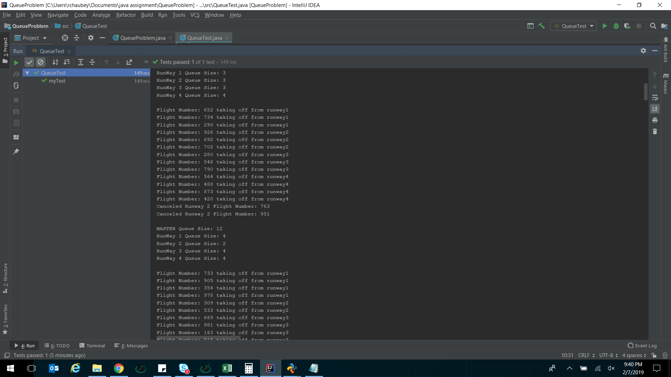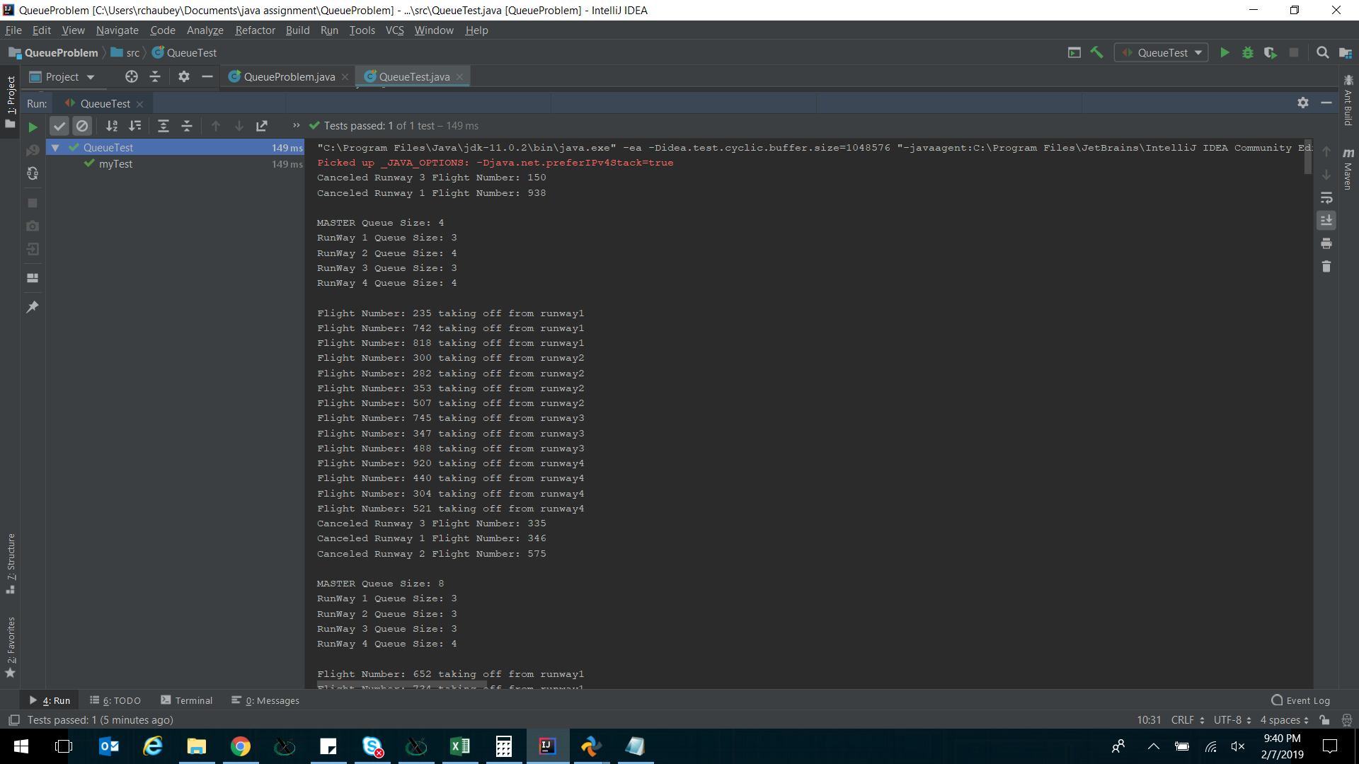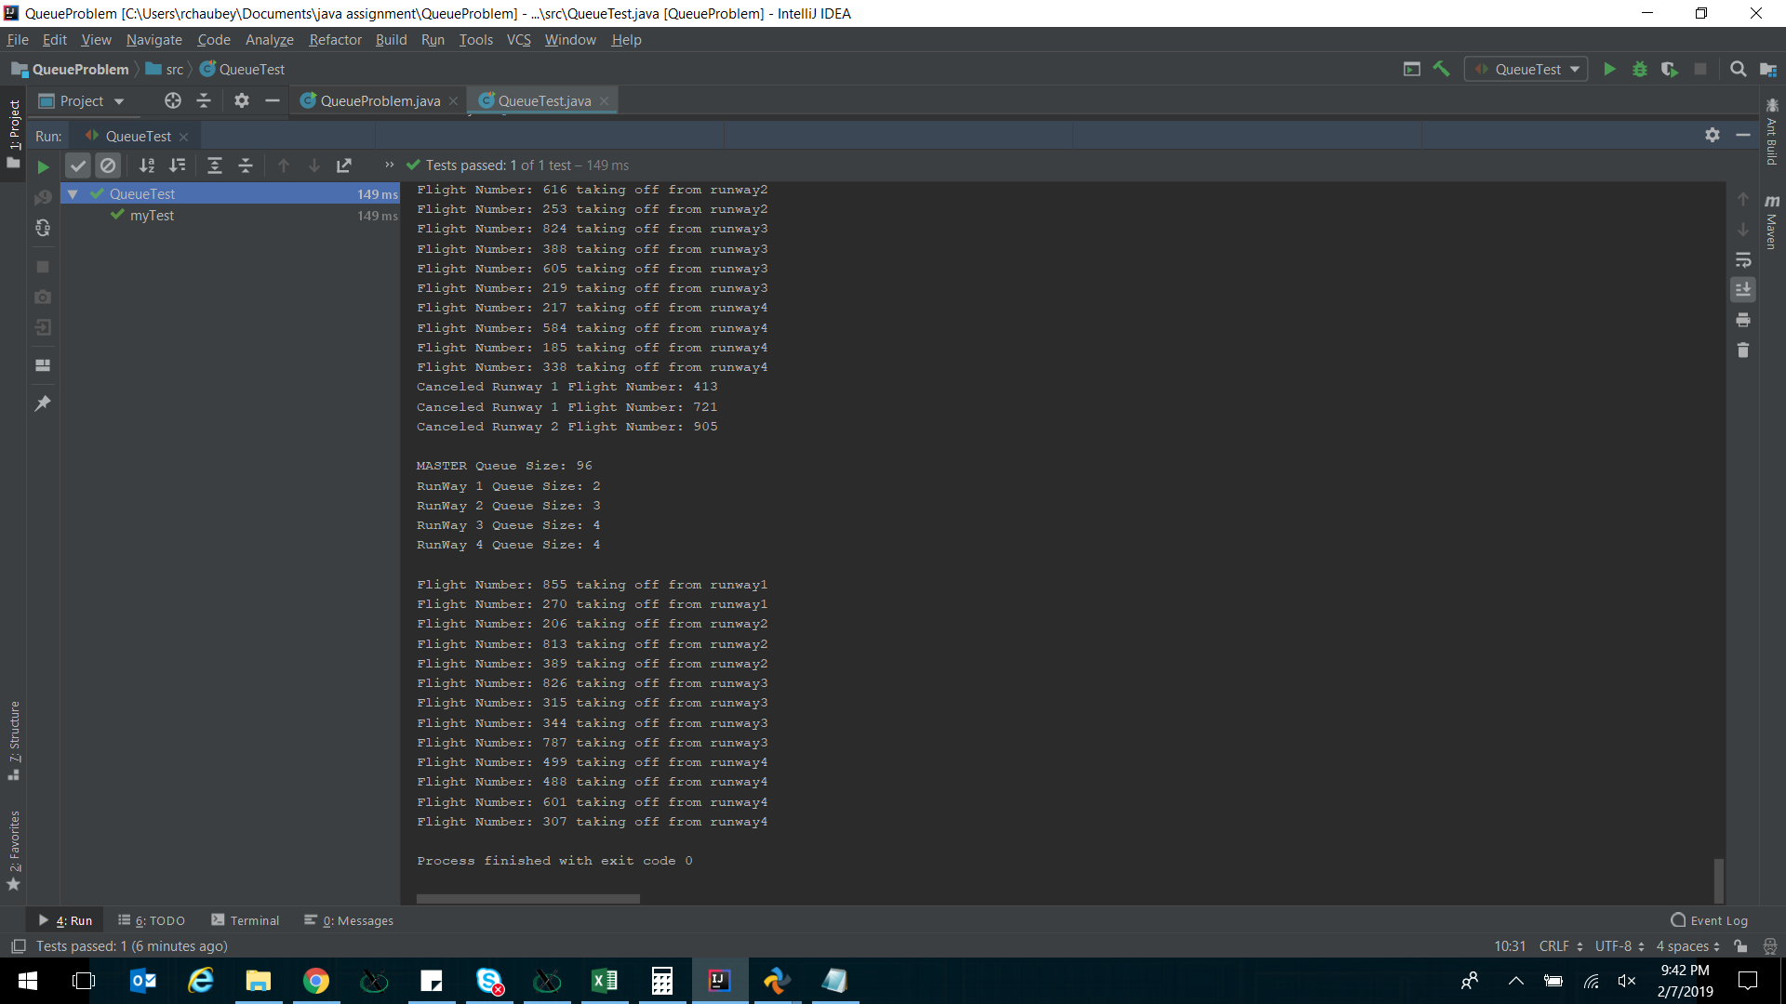

**Array:**

**Introduction:**

Java array are collections of a data type which lie in memory next to each other. Hence an array can be indexed randomly unlike a linkedlist which needs to be traversed to get to a data block. Arrays are good if we want to do random reads/writes and not changing size of data set too frequently. Changing array size dynamically at runtime requires copying over to a new array.

**Problem:**

Use array to take transpose of an input matrix. Use qunit assertions to verify the final matrix’s dimensions and contents. Use junit to verify.

**Code:**

public class ArrayProblem {  
  
 //Original matrix  
 int OrigM[][];  
  
 //Transpose Matrix will have its dimensions inversed.  
 //(i,j) element of Original matrix will become (j,i) element of Transpose matrix  
 int TransposeM[][];  
  
 void doTranspose(){  
 OrigM = new int[3][2];  
 OrigM[0][0] = 5;  
 OrigM[0][1] = 7;  
 OrigM[1][0] = 11;  
 OrigM[1][1] = 8;  
 OrigM[2][0] = 54;  
 OrigM[2][1] = 9;  
  
  
 int row = OrigM.length;  
 int col = OrigM[0].length;  
  
 TransposeM = new int[col][row];  
  
 for(int i=0; i<row; i++){  
 for(int j=0; j<col; j++){  
 TransposeM[j][i] = OrigM[i][j];  
 }  
 }  
  
 String RowS = "";  
 System.*out*.println("\nOriginal Matrix:");  
  
 for(int i=0; i<row; i++){  
 for(int j=0; j<col; j++){  
 RowS = RowS + " " + String.*valueOf*(OrigM[i][j]);  
 }  
 System.*out*.println(RowS);  
 RowS = "";  
 }  
  
 row = TransposeM.length;  
 col = TransposeM[0].length;  
  
 System.*out*.println("\nTranspose Matrix:");  
  
 for(int i=0; i<row; i++){  
 for(int j=0; j<col; j++){  
 RowS = RowS + " " + String.*valueOf*(TransposeM[i][j]);  
 }  
 System.*out*.println(RowS);  
 RowS = "";  
 }  
  
 }  
  
 public static void main(String args[]) {  
  
 ArrayProblem ap = new ArrayProblem();  
 ap.doTranspose();  
  
 }  
}

import org.junit.Assert;  
import org.junit.Test;  
  
import static junit.framework.TestCase.*assertEquals*;  
import static junit.framework.TestCase.*assertTrue*;  
  
public class ArrayTest {  
 @Test  
 public void myTest() {  
 ArrayProblem arraytester = new ArrayProblem();  
 arraytester.doTranspose();  
  
 Assert.*assertTrue*("Original Matrix Can't be null", arraytester.OrigM != null);  
 Assert.*assertTrue*("Transpose Matrix Can't be null", arraytester.TransposeM != null);  
 Assert.*assertEquals*(arraytester.OrigM.length,arraytester.TransposeM[0].length);  
 Assert.*assertEquals*(arraytester.OrigM[0].length,arraytester.TransposeM.length);  
  
 Assert.*assertEquals*(arraytester.OrigM[0][0],arraytester.TransposeM[0][0]);  
 Assert.*assertEquals*(arraytester.OrigM[0][1],arraytester.TransposeM[1][0]);  
 Assert.*assertEquals*(arraytester.OrigM[1][0],arraytester.TransposeM[0][1]);  
 Assert.*assertEquals*(arraytester.OrigM[1][1],arraytester.TransposeM[1][1]);  
 Assert.*assertEquals*(arraytester.OrigM[2][0],arraytester.TransposeM[0][2]);  
 Assert.*assertEquals*(arraytester.OrigM[2][1],arraytester.TransposeM[1][2]);  
  
}  
}

**Results:**

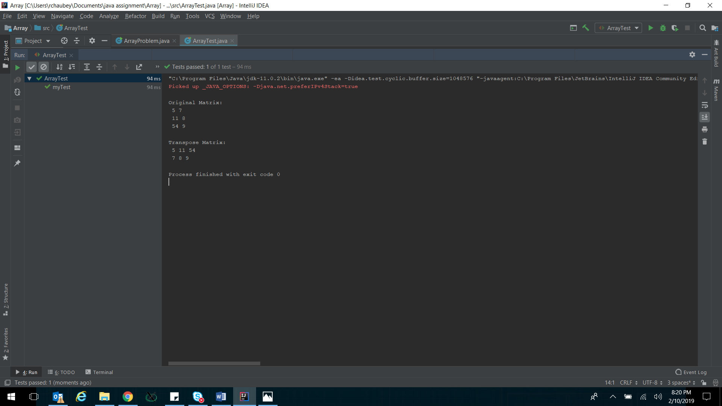

**Collections:**

**Introduction:**

Java collections framework is inbuilt set of classes in java which provides in-built functions to hold and manipulate data set using structures like List, ArrayList, LinkedList, Queue, Vector etc

**Problem:**

For this problem I have taken idea from my undergrad internship at Hewitt Packard (HP).

I am modelling basic functionality of a DRAM memory controller.

Memory controller has write and read queue which keeps getting populated by requests coming from CPU. Memory controller selects a request out of read or write queue and send it to DRAM. Memory controller always gives reads higher priority over writes as CPU is waiting for read data. But when write queue fills up till a threshold, memory controller switches to start taking care of writes until write queue size goes below that threshold. Model this functionality using java collections. Use junit to verify.

**Code:**

import java.util.LinkedList;  
import java.util.Random;  
  
class CpuRequest {  
 String type;  
 int address;  
  
 CpuRequest( String type) {  
 Random rand = new Random();  
 this.type = type;  
 address = rand.nextInt(983401) + 65535; //Rand address between 0xFFFF to 0XF_FFFF  
 }  
}  
  
class Cpu {  
  
 //Read Queue  
 LinkedList<CpuRequest> ReadQ = new LinkedList<>();  
 //Write Queue  
 LinkedList<CpuRequest> WriteQ = new LinkedList<>();  
  
 void generateReq(){  
 Random rand = new Random();  
 int rdbias;  
 rdbias = rand.nextInt(4); //random number 0,1,2,3  
 if(rdbias == 0 && WriteQ.size() < 20){ // Generate Write Request with 1/4 probability  
 WriteQ.addFirst(new CpuRequest("Wr"));  
 } else if(ReadQ.size() < 20){ // Generate Read Request with 3/4 probability  
 ReadQ.addFirst(new CpuRequest("Rd"));  
 }  
 }  
}

import org.junit.*;  
  
public class CollectionsTest {  
 @Test  
 public void myTest() {  
  
 Cpu cpu = new Cpu();  
 int WrDrainThreashold = 10;  
  
 //populate initial read and write requests.  
 for(int i=0;i<20;i++){  
 cpu.generateReq();  
 }  
 System.*out*.println("ReadQ length: "+cpu.ReadQ.size());  
 System.*out*.println("WriteQ length: "+cpu.WriteQ.size());  
  
 Assert.*assertTrue*("ReadQ size must be less than 20", cpu.ReadQ.size() < 20);  
 Assert.*assertTrue*("WriteQ size must be less than 20", cpu.WriteQ.size() < 20);  
  
 int numTX = 1;  
 while(numTX <= 100){  
 System.*out*.println("Transaction # "+numTX);  
 if(cpu.WriteQ.size() <= WrDrainThreashold){  
 System.*out*.println("Mem Scheduler sending: "+cpu.ReadQ.getLast().type+" Address: 0x"+Integer.*toHexString*(cpu.ReadQ.getLast().address));  
 Assert.*assertTrue*(cpu.ReadQ.size() >= 1);  
 cpu.ReadQ.removeLast();  
 } else {  
 System.*out*.println("Mem Scheduler sending: "+cpu.WriteQ.getLast().type+" Address: 0x"+Integer.*toHexString*(cpu.WriteQ.getLast().address));  
 Assert.*assertTrue*(cpu.WriteQ.size() >= 1);  
 cpu.WriteQ.removeLast();  
 }  
 cpu.generateReq();  
 numTX++;  
 System.*out*.println("ReadQ length: "+cpu.ReadQ.size());  
 System.*out*.println("WriteQ length: "+cpu.WriteQ.size()+"\n");  
 Assert.*assertTrue*("ReadQ size must be less than 20", cpu.ReadQ.size() < 20);  
 Assert.*assertTrue*("WriteQ size must be less than 20", cpu.WriteQ.size() < 20);  
 Assert.*assertTrue*("numTX must be less than 100", numTX <= 101);  
  
  
 }  
  
 }  
  
}

**Results:**

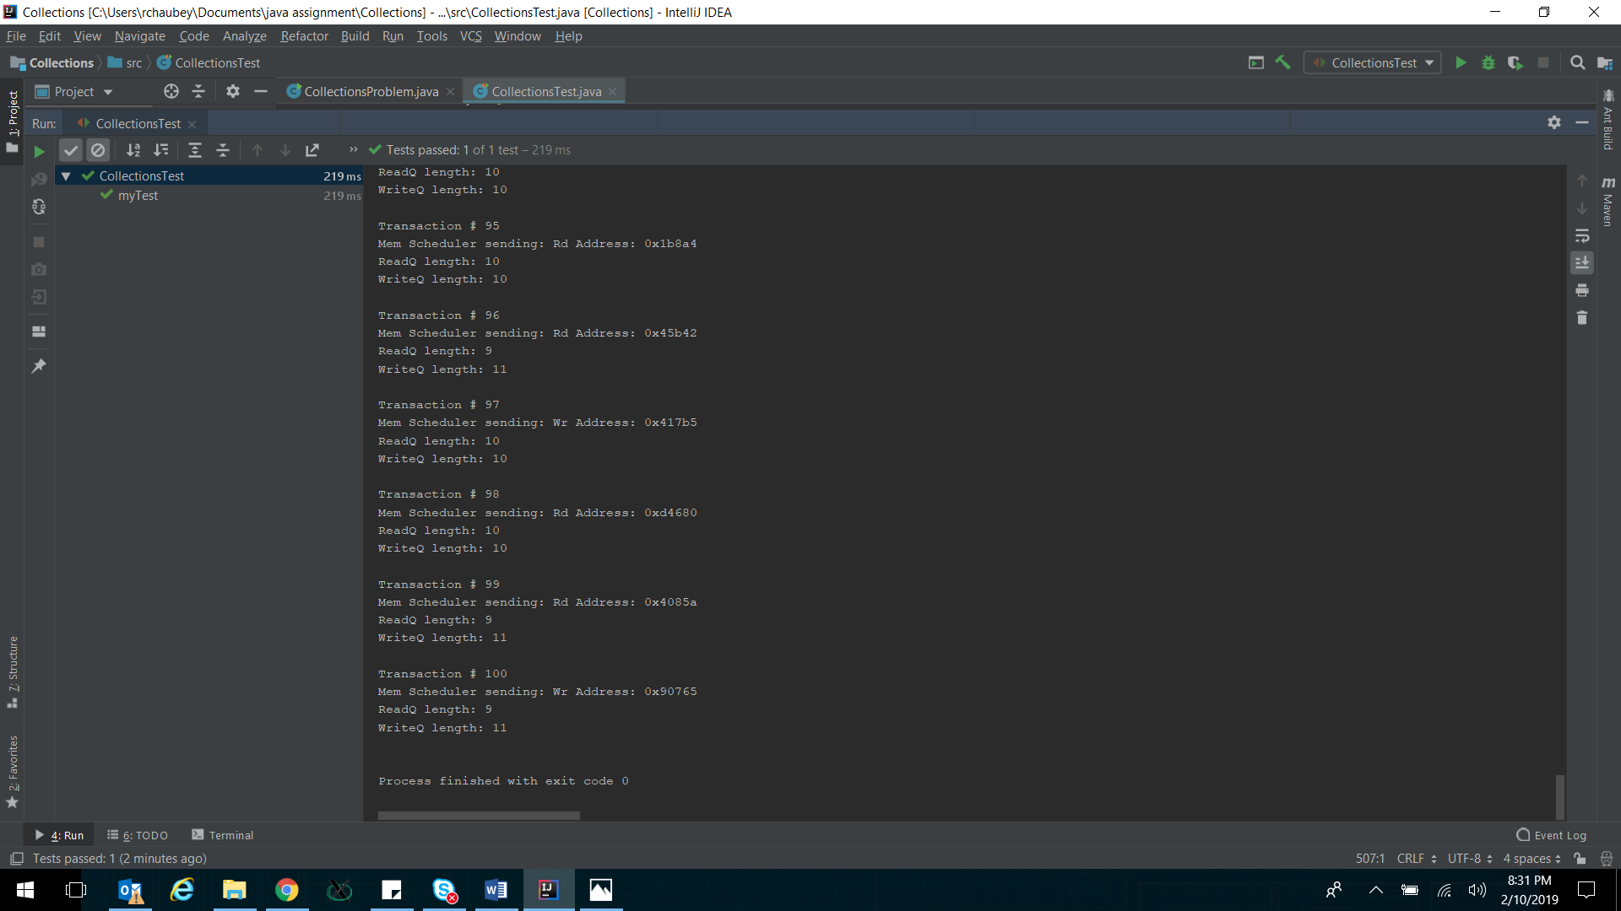

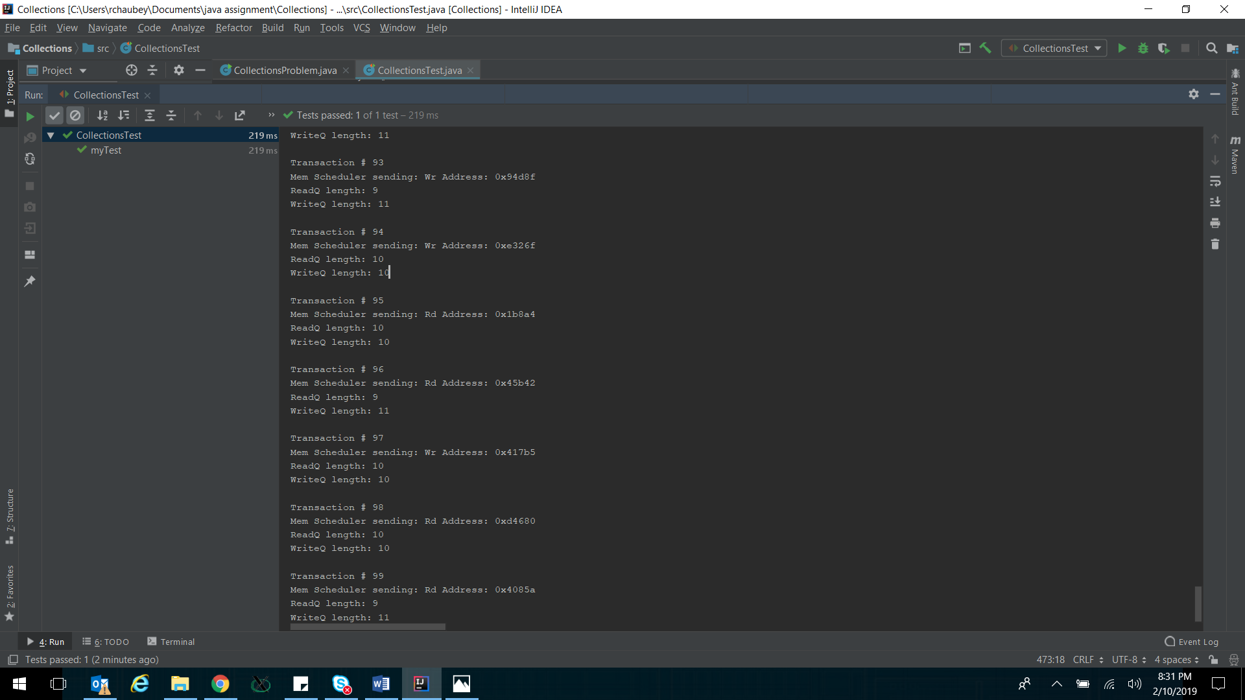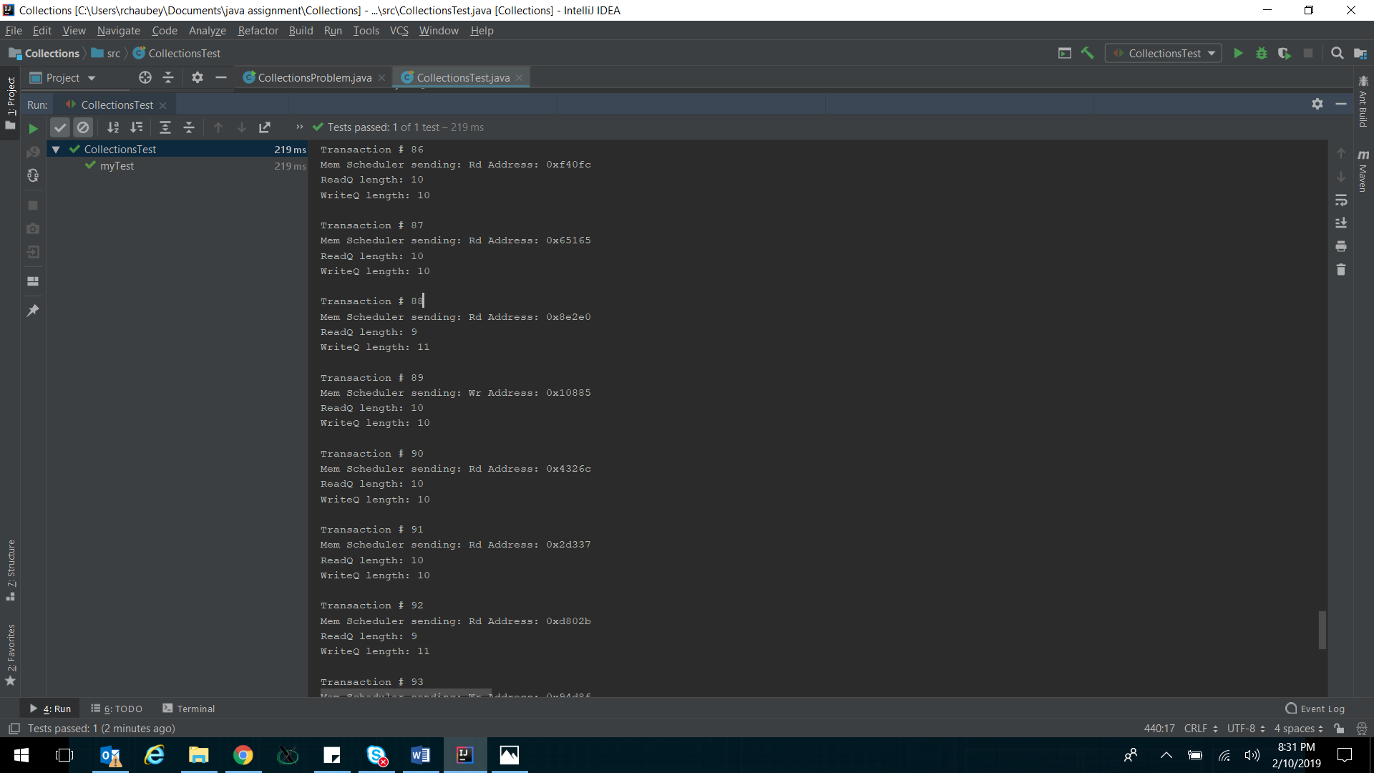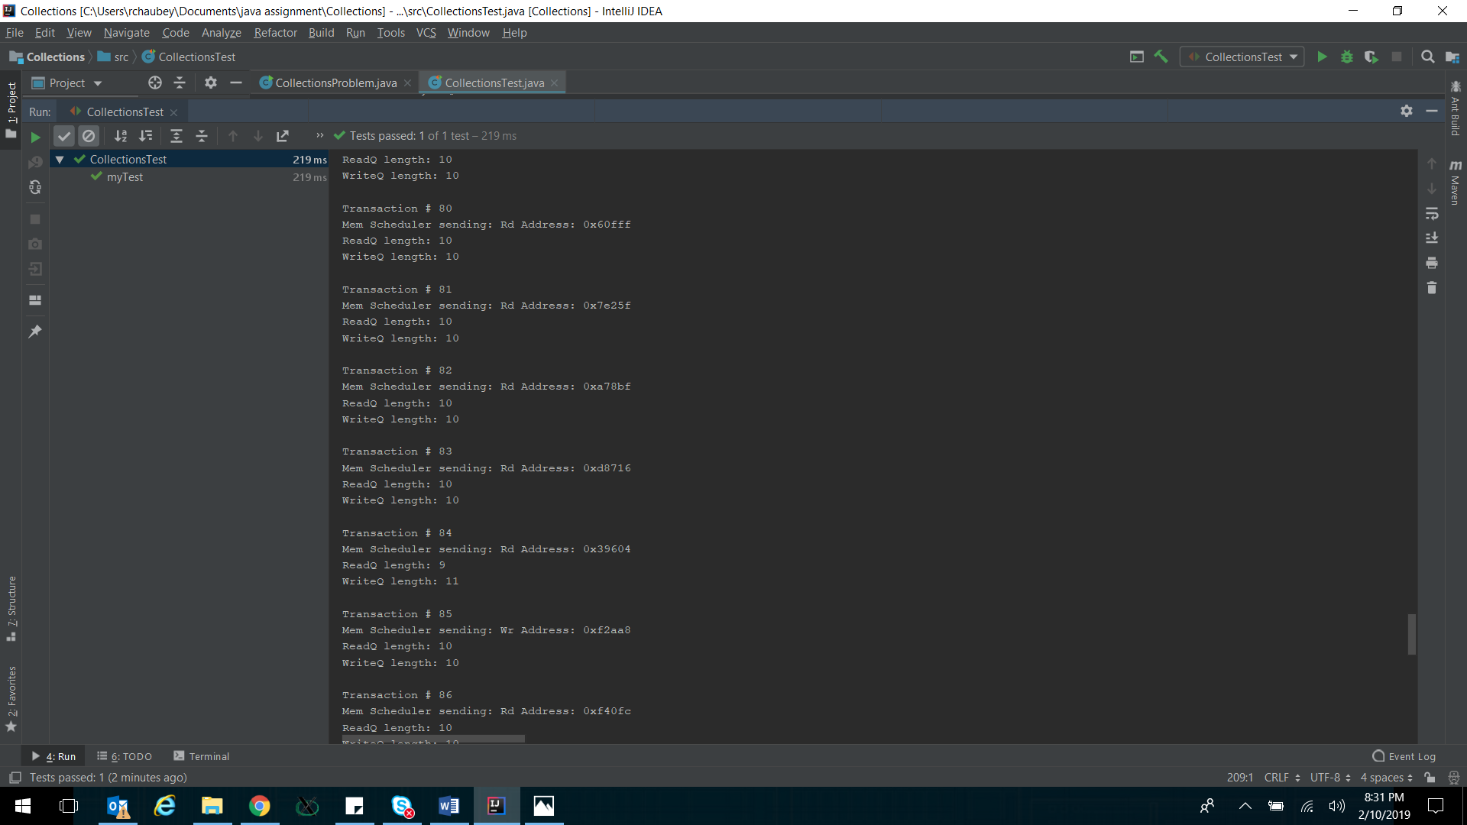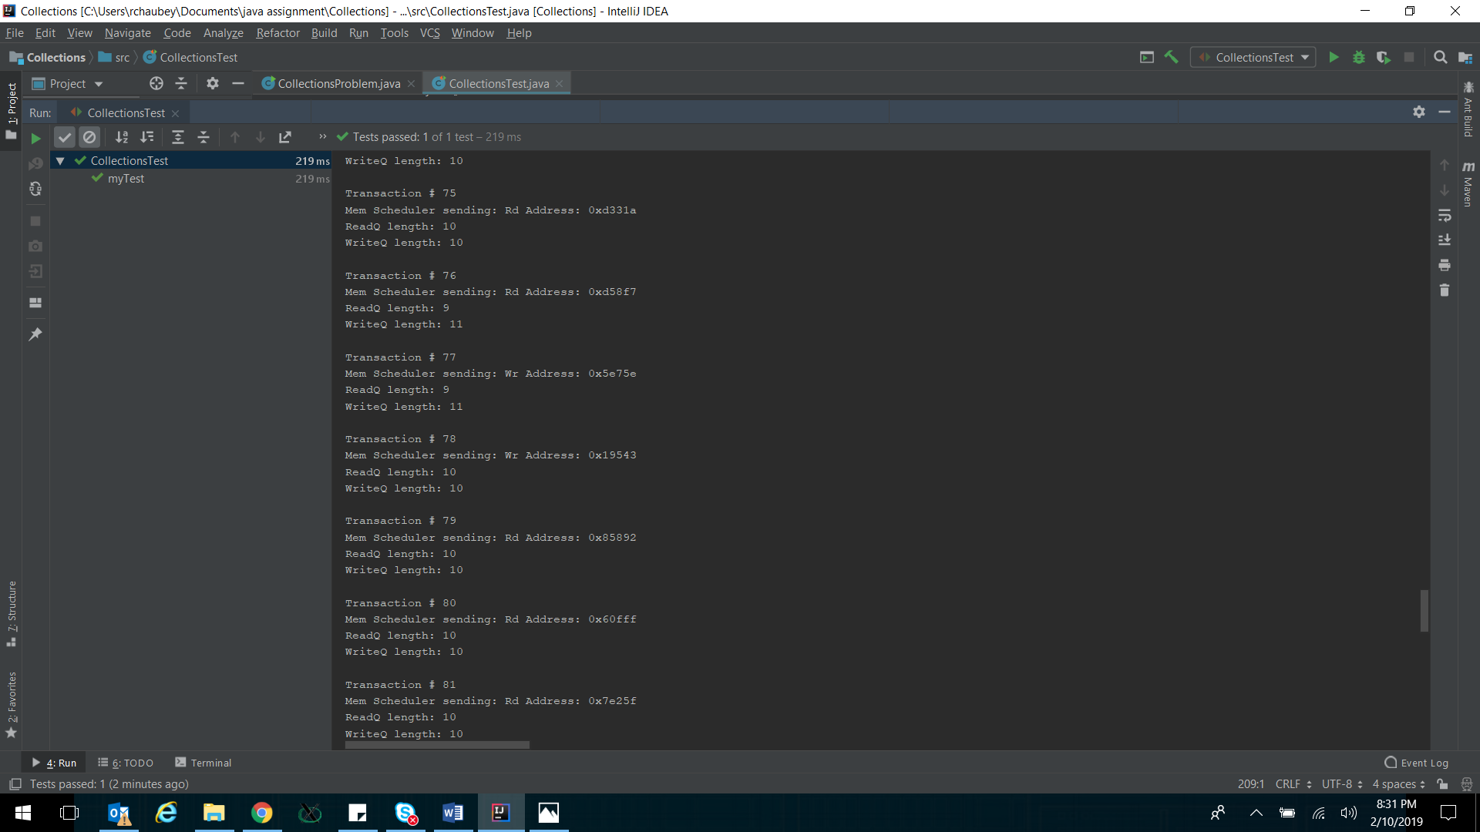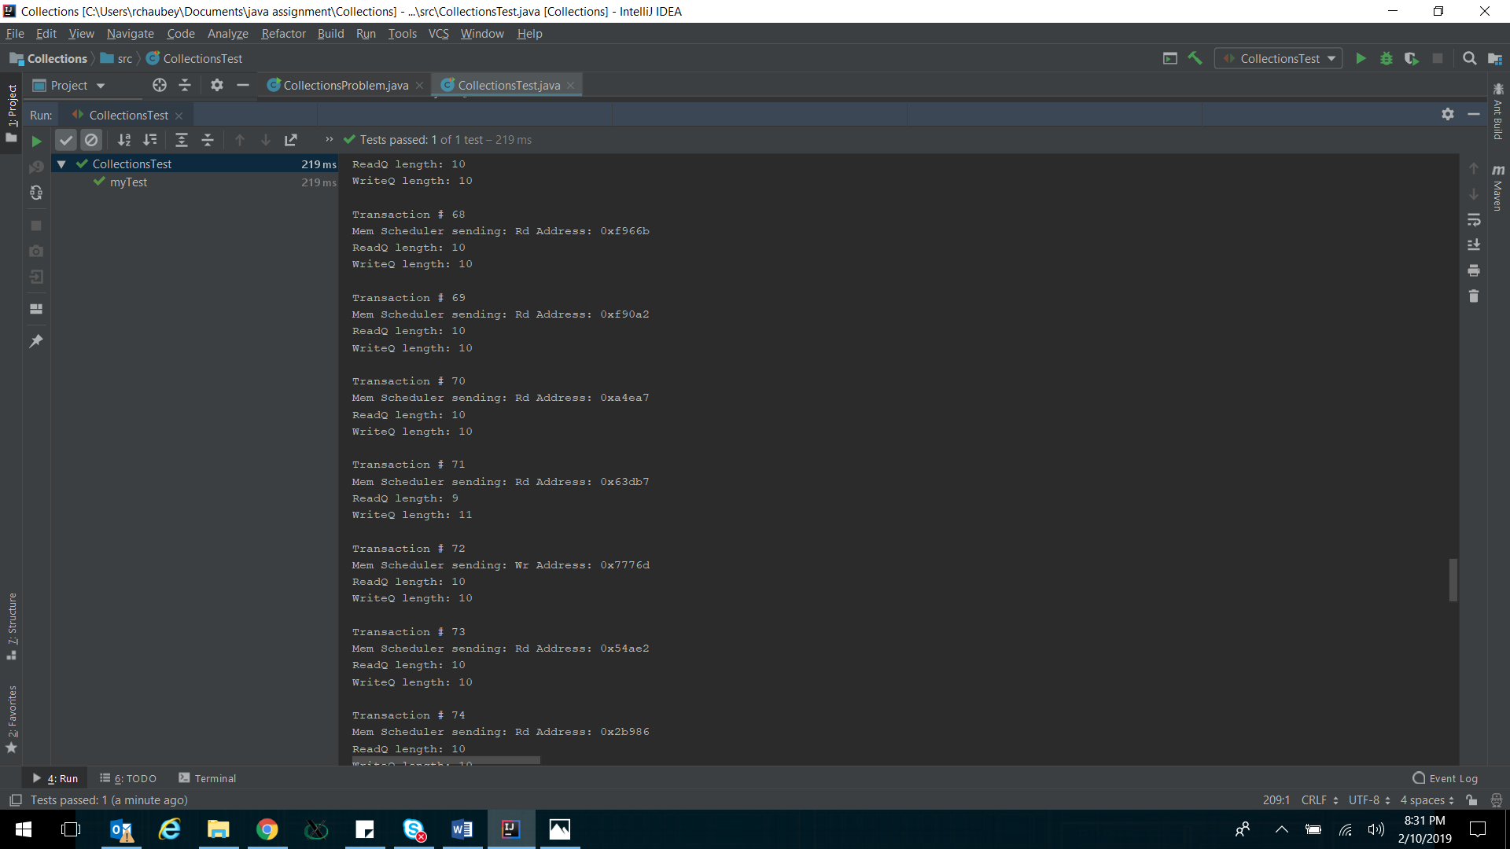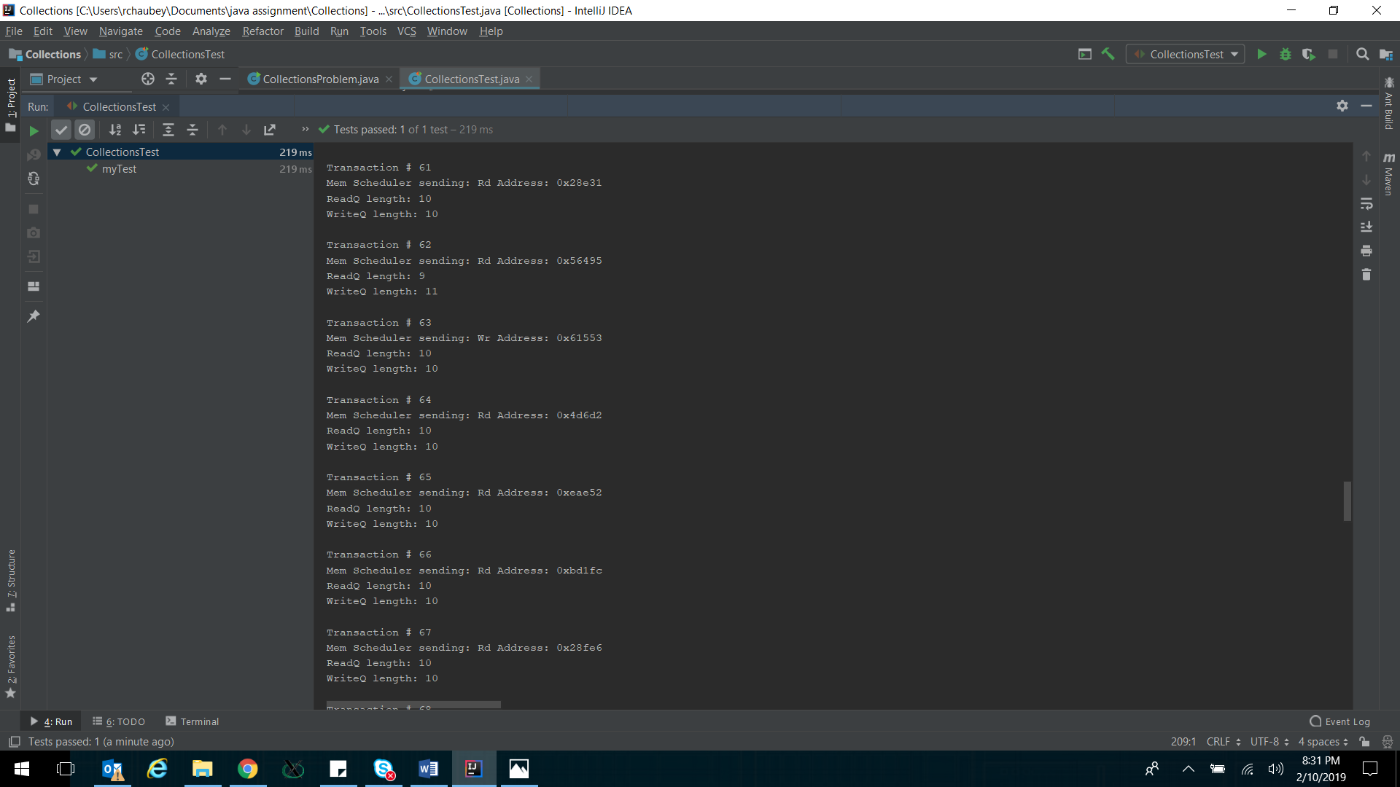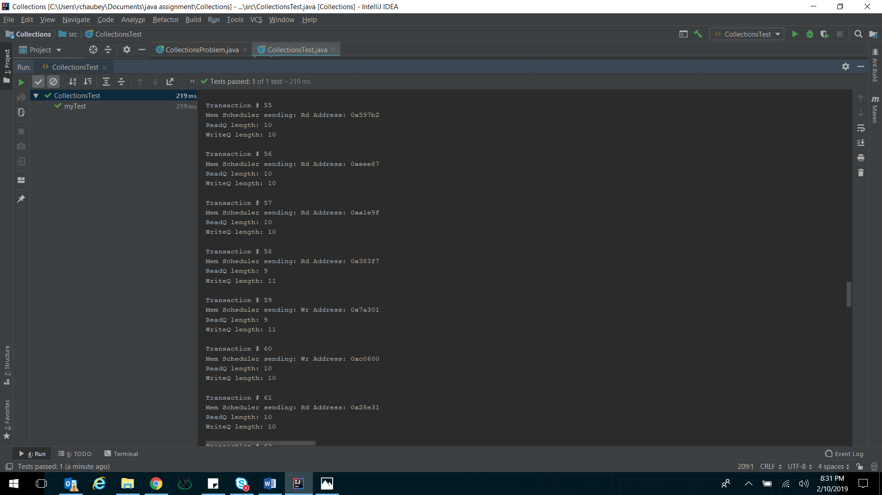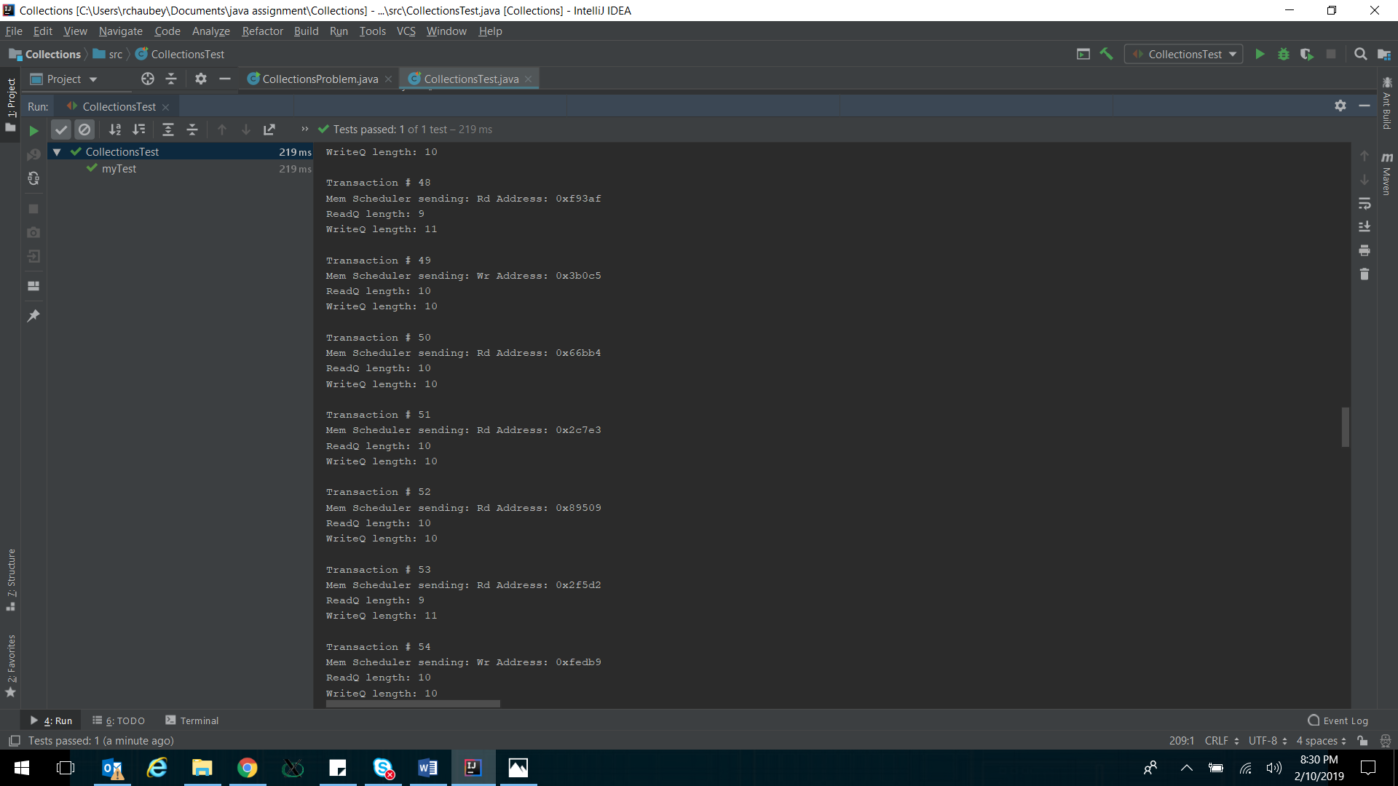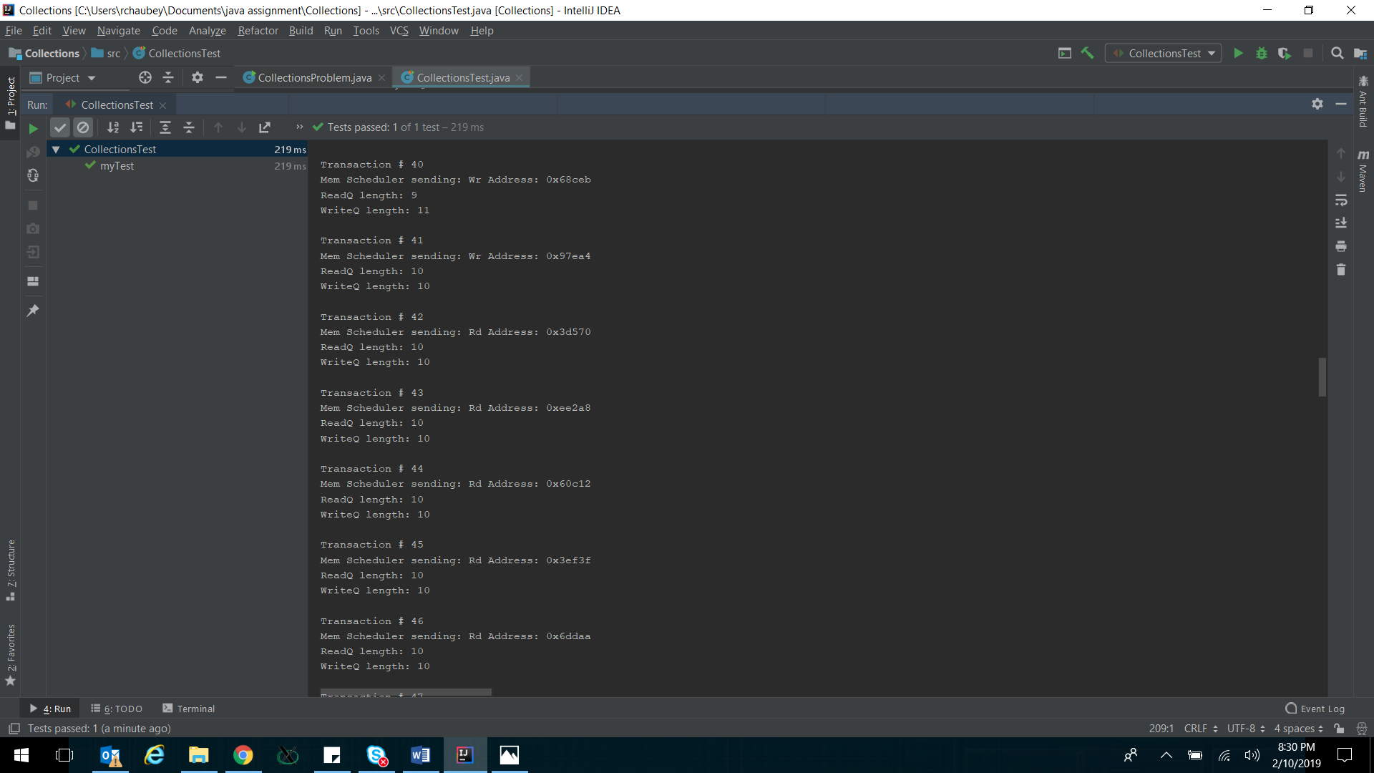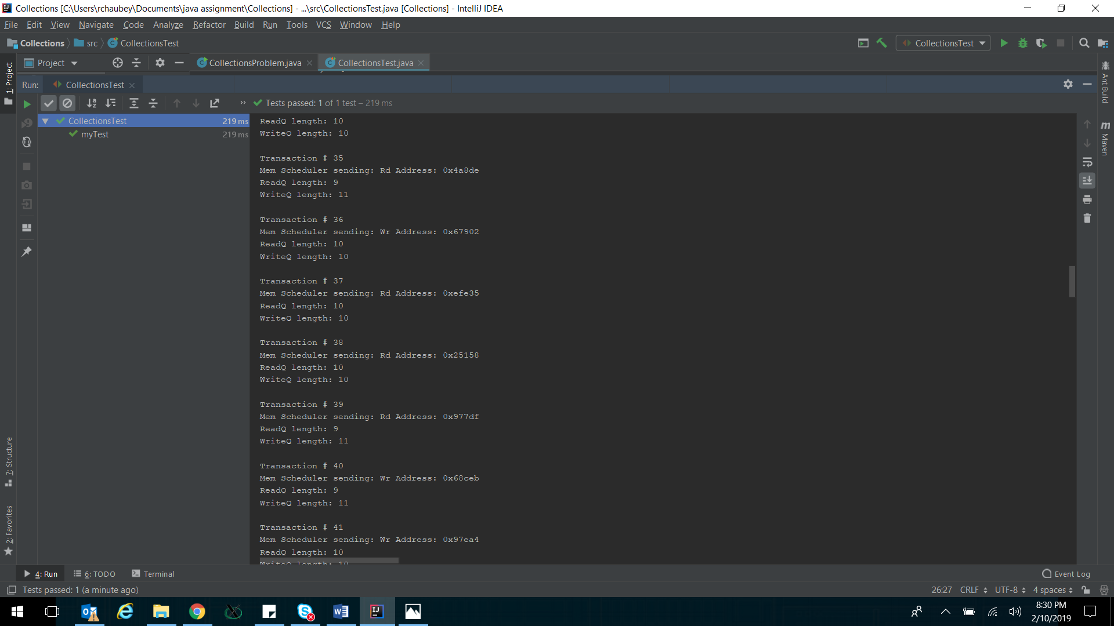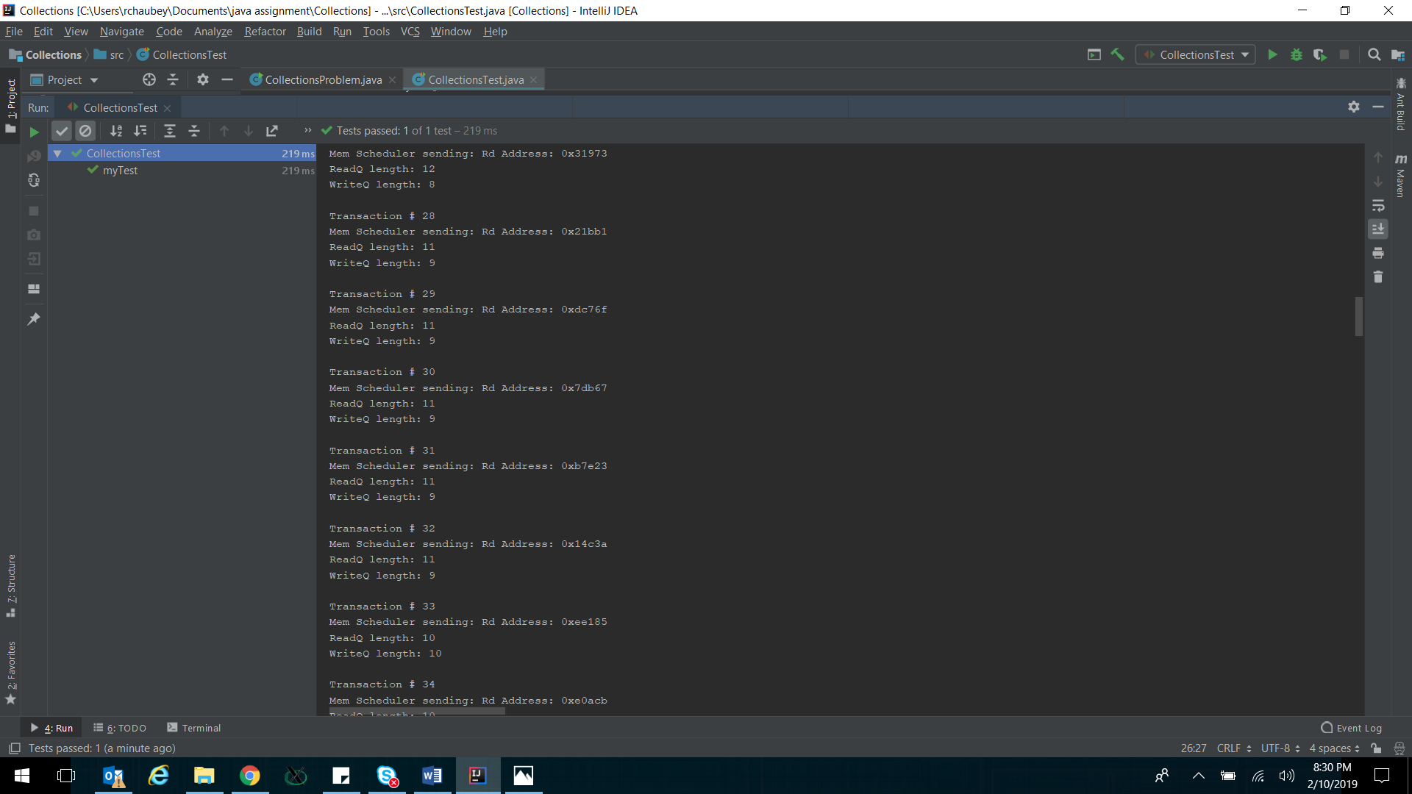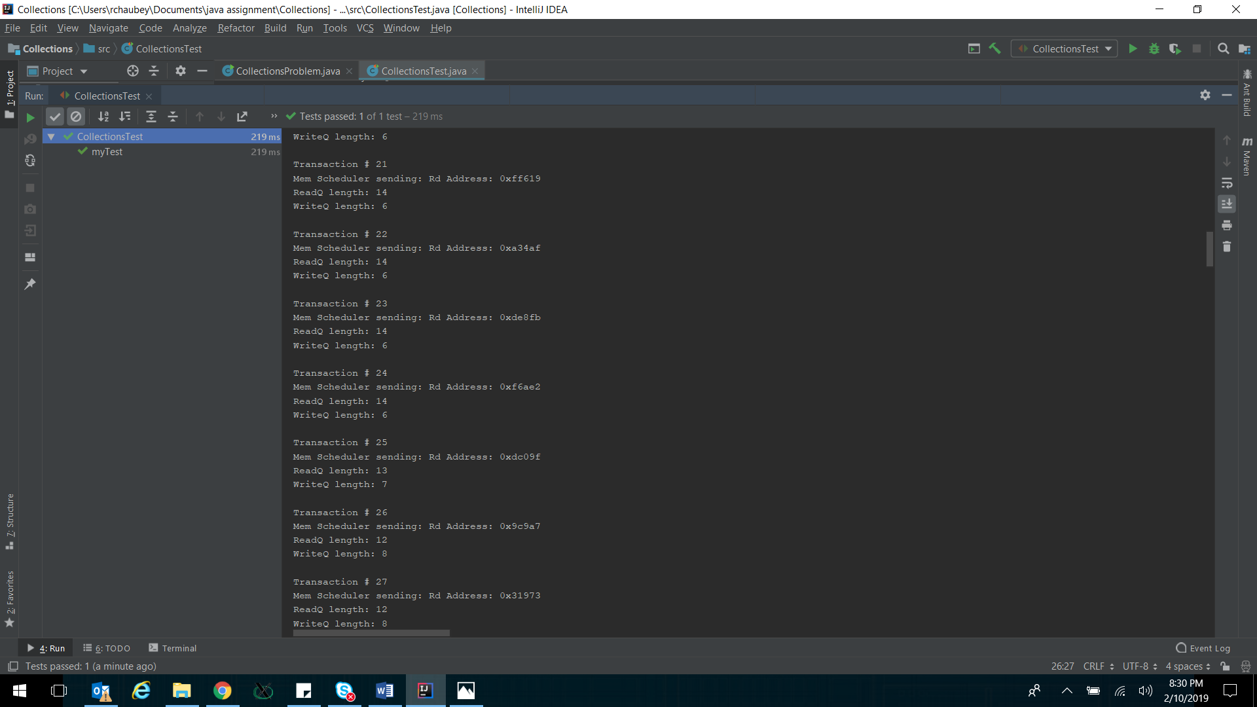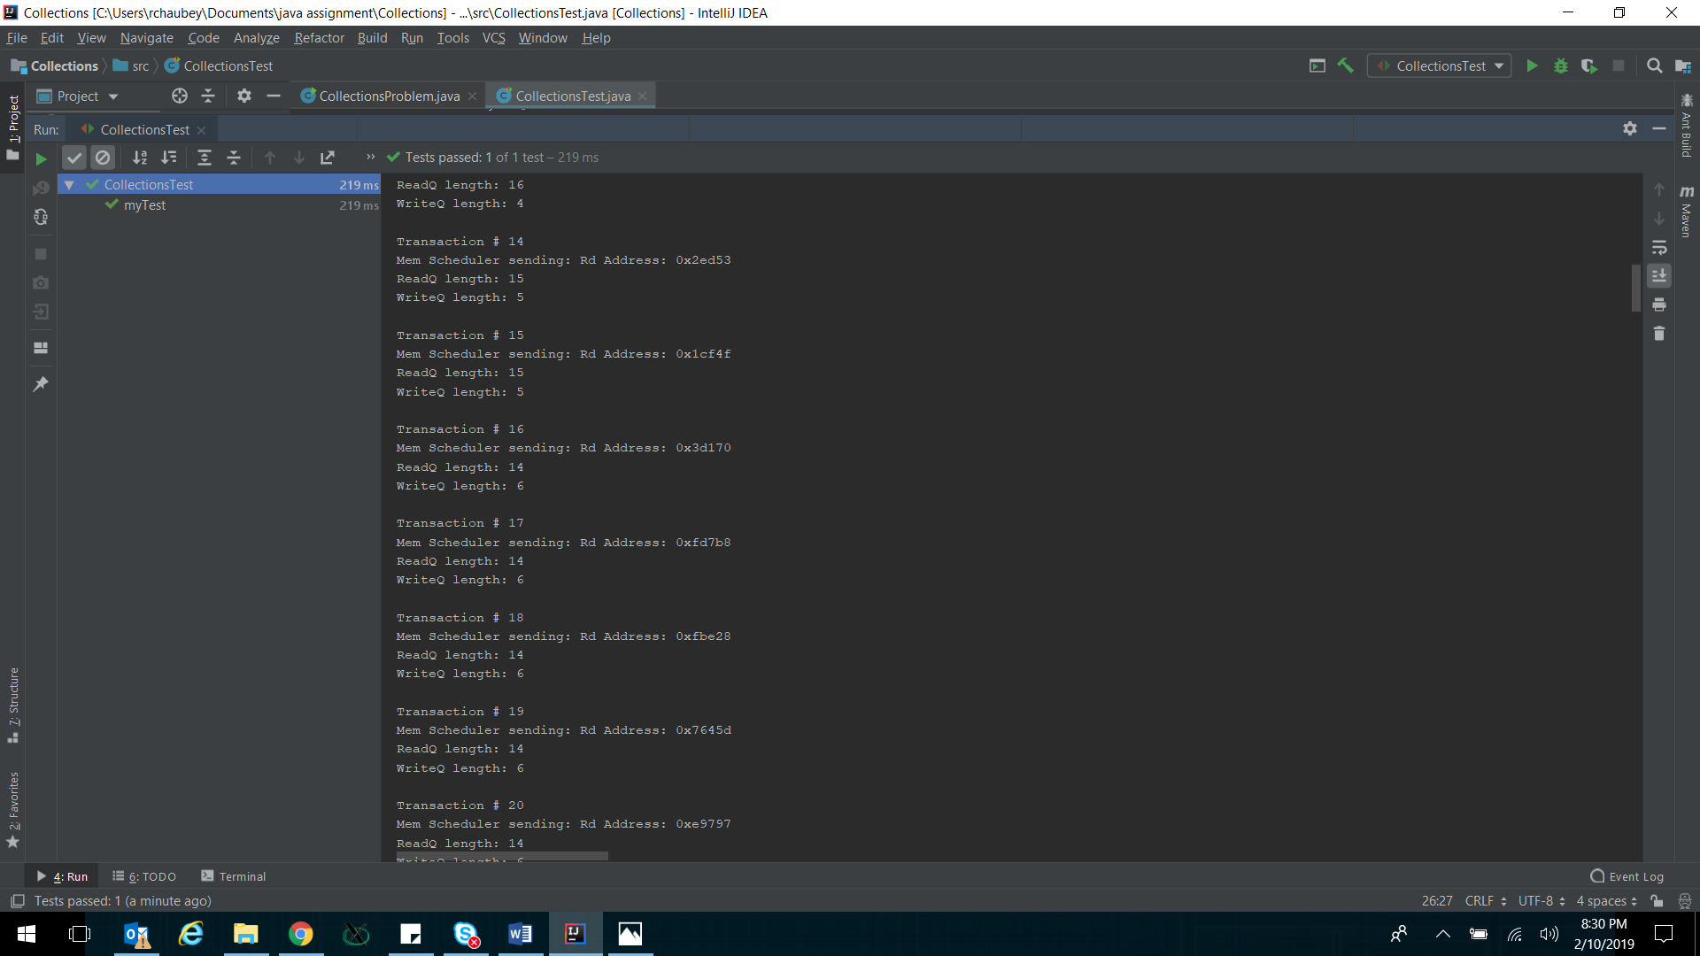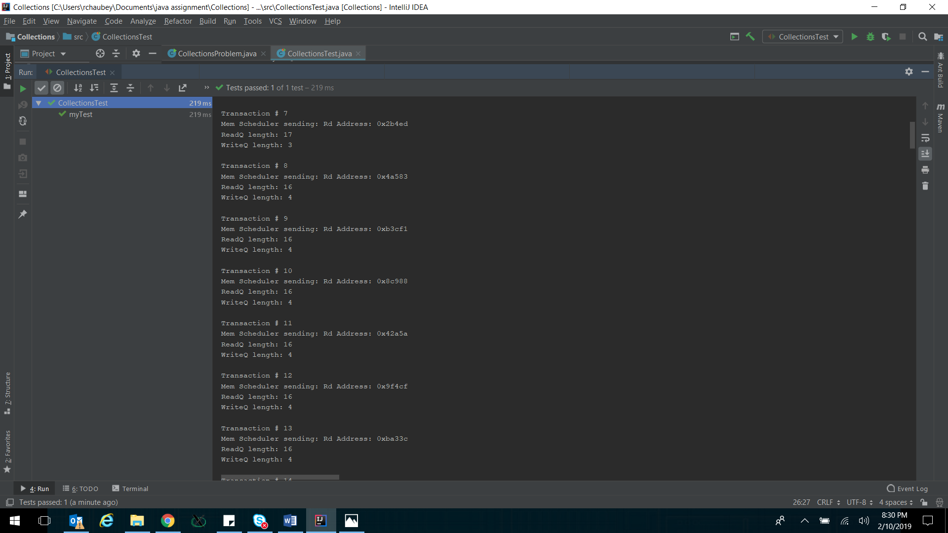

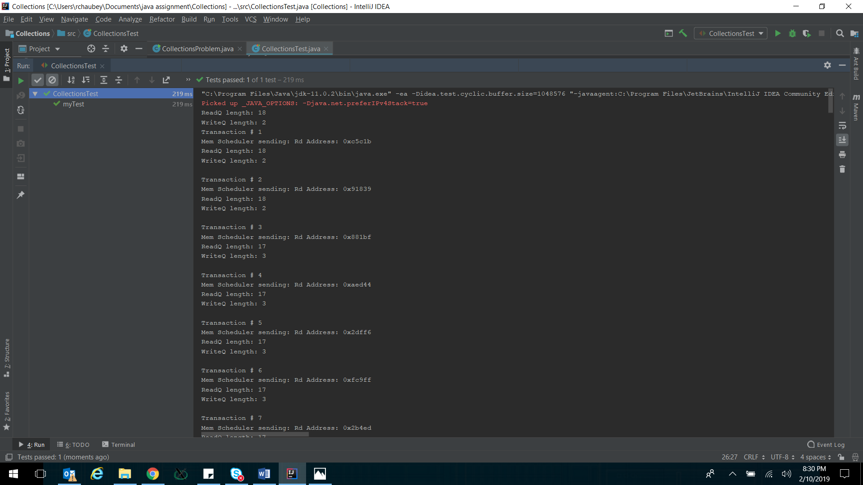

**Multi-threading:**

**Introduction:**

Multi-threading in java is implemented using Thread Class which implements Runnable interface. Every thread needs to override run() of Thread class to do its own task.

If two or more thread access and manipulates same object, we need to use synchronized functions or blocks in object so that threads are required to get hold of lock before changing shared data. For communication to other threads functions such a wait(), notify(), and notifyall() are used.

**Problem:**

Sorting and search using multi-threading in java. One common operation done on data bases is to sort the data first and then use sorted data for searching purposes. Search algorithms are faster on sorted data.

Thread 1: Sorter thread will sort the input arraylList and notify other searcher threads that sorting is done. On notification searcher threads will wake up, get the lock to the list object and start searching in the array list for given inputs. Using one sorter thread and three searcher threads in the code. Use junit to verify.

**Code:**

import java.util.ArrayList;  
import java.util.Collections;  
import java.util.stream.Collectors;  
  
class DataBase {  
  
 ArrayList<Integer> dataList; // List  
 boolean sortingDone;  
 String sortedList;  
  
 DataBase(ArrayList<Integer> list){ // Constructor  
 dataList = list;  
 sortingDone = false;  
 }  
  
 synchronized void sortme() {  
 System.*out*.println(Thread.*currentThread*().getName() + " is Sorting");  
 Collections.*sort*(dataList);  
 String listString = dataList.stream().map(Object::toString)  
 .collect(Collectors.*joining*(", "));  
 System.*out*.println("Sorted List is:\n"+listString+"\n"+Thread.*currentThread*().getName() + " is done");  
 sortingDone = true;  
 this.sortedList = listString;  
 notifyAll();  
 }  
  
 synchronized int searchme(int input){  
  
 while (sortingDone == false){  
 try{wait();}catch(Exception e){};  
 }  
  
 System.*out*.println(Thread.*currentThread*().getName() + " is now Searching");  
 int retval = dataList.indexOf(input);  
 if(retval == -1) {  
 System.*out*.println(Thread.*currentThread*().getName()+" says input "+input+" is not present in list");  
 } else {  
 System.*out*.println(Thread.*currentThread*().getName()+" returning index: "+retval+" of input "+input);  
 }  
 return retval;  
 }  
  
}

import org.junit.Assert;  
import org.junit.Test;  
  
import java.util.ArrayList;  
  
public class MultithreadingTest {  
  
 @Test  
 public void myTest() {  
 ArrayList<Integer> initArray = new ArrayList<Integer>();  
 ArrayList<Integer> finalArray = new ArrayList<Integer>();  
  
 initArray.add(23);  
 initArray.add(4);  
 initArray.add(56);  
 initArray.add(78);  
 initArray.add(243);  
 initArray.add(13);  
 initArray.add(88);  
 initArray.add(45);  
 initArray.add(61);  
 initArray.add(35);  
  
 DataBase DB_obj = new DataBase(initArray);  
  
 String expectedString = "4, 13, 23, 35, 45, 56, 61, 78, 88, 243";  
  
 finalArray.add(4);  
 finalArray.add(13);  
 finalArray.add(23);  
 finalArray.add(35);  
 finalArray.add(45);  
 finalArray.add(56);  
 finalArray.add(61);  
 finalArray.add(78);  
 finalArray.add(88);  
 finalArray.add(243);  
  
 Thread t1 = new Thread() {  
 @Override  
 public void run() {  
 DB_obj.sortme();  
 }  
 };  
 t1.setName("Sorter_Thread");  
  
 Thread t2 = new Thread() {  
 @Override  
 public void run() {  
 DB_obj.searchme(88);  
 }  
 };  
 t2.setName("First_Searcher_Thread");  
  
 Thread t3 = new Thread() {  
 @Override  
 public void run() {  
 DB_obj.searchme(7);  
 }  
 };  
 t3.setName("Second_Searcher_Thread");  
  
 Thread t4 = new Thread() {  
 @Override  
 public void run() {  
 DB_obj.searchme(35);  
 }  
 };  
 t4.setName("Third_Searcher_Thread");  
  
 t1.start();  
 t2.start();  
 t3.start();  
 t4.start();  
  
 try{t1.join();}catch(Exception e){};  
 try{t2.join();}catch(Exception e){};  
 try{t3.join();}catch(Exception e){};  
 try{t4.join();}catch(Exception e){};  
  
 Assert.*assertEquals*(DB_obj.dataList, finalArray);  
  
  
 }  
 }

**Results:**

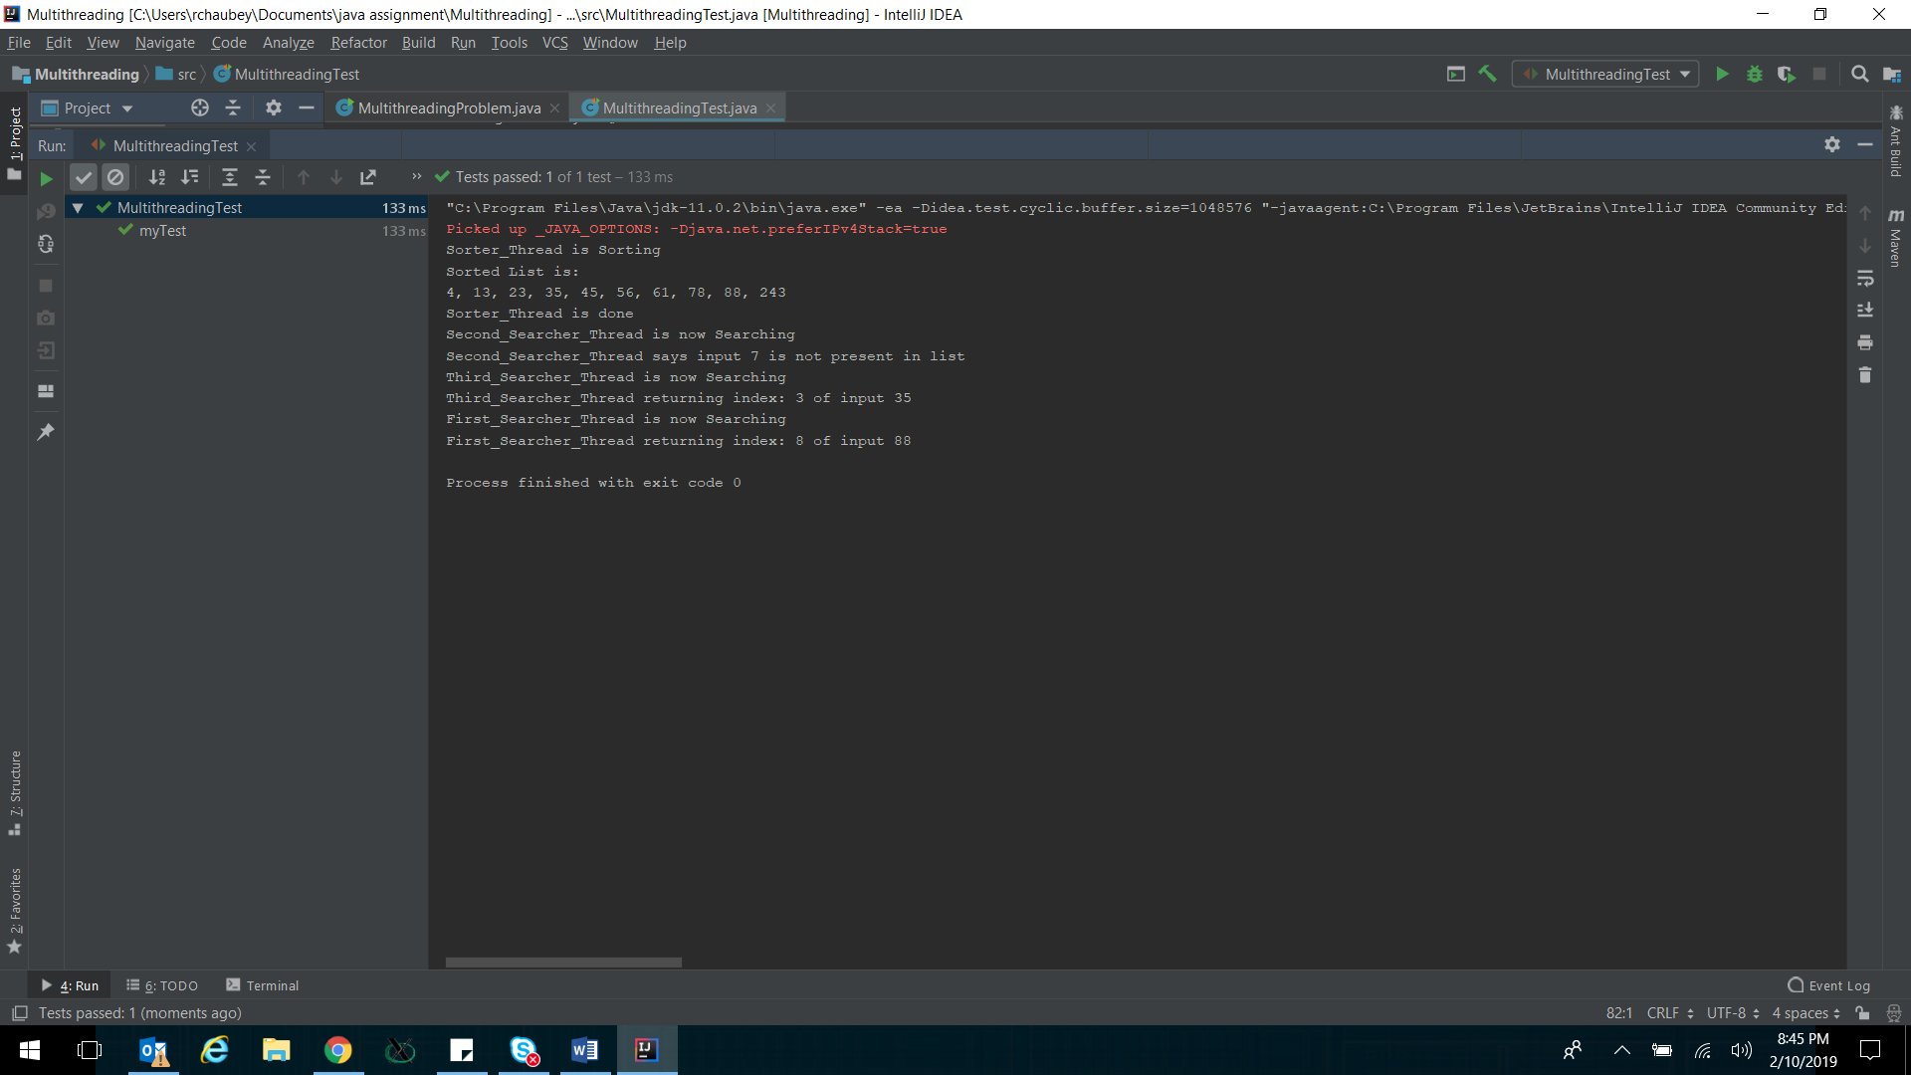

**Interfaces:**

**Introduction:**

Interfaces are used in java to provide a template/guidance for other classes which are then supposed to extends from interface and implement functions defined in interface. All functions in interface are always abstract and all variables are static final.

**Problem:**

Using interface as template to implement two versions of interest calculation by two banks for a fixed term fixed deposit. Using interface type reference to invoke two versions of interest calculations using upcasting. Use junit to verify.

**Code:**

interface bankOperations{  
 void deposit(int x); //Deposit money in account  
 void withdraw(int y); //Withdraw money account  
 int fixDepositReturn(int principal, int years); //Calculate final return on a fixed deposit for given years  
  
}  
  
class JPMorganChase implements bankOperations{  
  
 int balance;  
 int rate;  
  
 JPMorganChase(){  
 balance = 0;  
 rate = 5;  
 }  
  
 public void deposit(int x){  
 balance+=x;  
 System.*out*.println("JPMorganChase balance after deposit: "+balance);  
 }  
 public void withdraw(int y){  
 balance-=y;  
 System.*out*.println("JPMorganChase balance after withdraw: "+balance);  
 }  
  
 public int fixDepositReturn(int principal, int years){ //Simple Interest  
 System.*out*.println("JPMorganChase offering simple interest");  
 int finalAmount= principal*(1+ rate*years);  
 System.*out*.println("JPMorganChase: Principal: "+principal+" years: "+years+" Amount: "+finalAmount);  
 return finalAmount;  
 }  
}  
  
class BankOfAmerica implements bankOperations{  
  
 int balance;  
 int rate;  
  
 BankOfAmerica(){  
 balance = 1000;  
 rate = 5;  
 }  
  
 public void deposit(int x){  
 balance+=x;  
 System.*out*.println("BankOfAmerica balance after deposit: "+balance);  
 }  
 public void withdraw(int y){  
 balance-=y;  
 System.*out*.println("BankOfAmerica balance after deposit: "+balance);  
 }  
  
 public int fixDepositReturn(int principal, int years){ //Compound Interest  
 System.*out*.println("BankOfAmerica offering compound interest");  
 double temp = Math.*pow*((double)(1+rate), (double)years);  
 int finalAmount= (int)((int)temp*principal);  
 System.*out*.println("BankOfAmerica: Principal: "+principal+" years: "+years+" Amount: "+finalAmount);  
 return finalAmount;  
 }  
}

import org.junit.*;  
  
  
public class InterfaceTest {  
  
 @Test  
 public void myTest() {  
  
 bankOperations Chase = new JPMorganChase(); //Upcasting  
 bankOperations BofA = new BankOfAmerica(); //Upcasting  
  
 int ChaseReturn = Chase.fixDepositReturn(5000, 3);  
 int BofAReturn = BofA.fixDepositReturn(5000, 3);  
  
 Assert.*assertTrue*("BofA return should be more than Chase return", BofAReturn > ChaseReturn);  
  
 }  
  
  
}

**Results:**

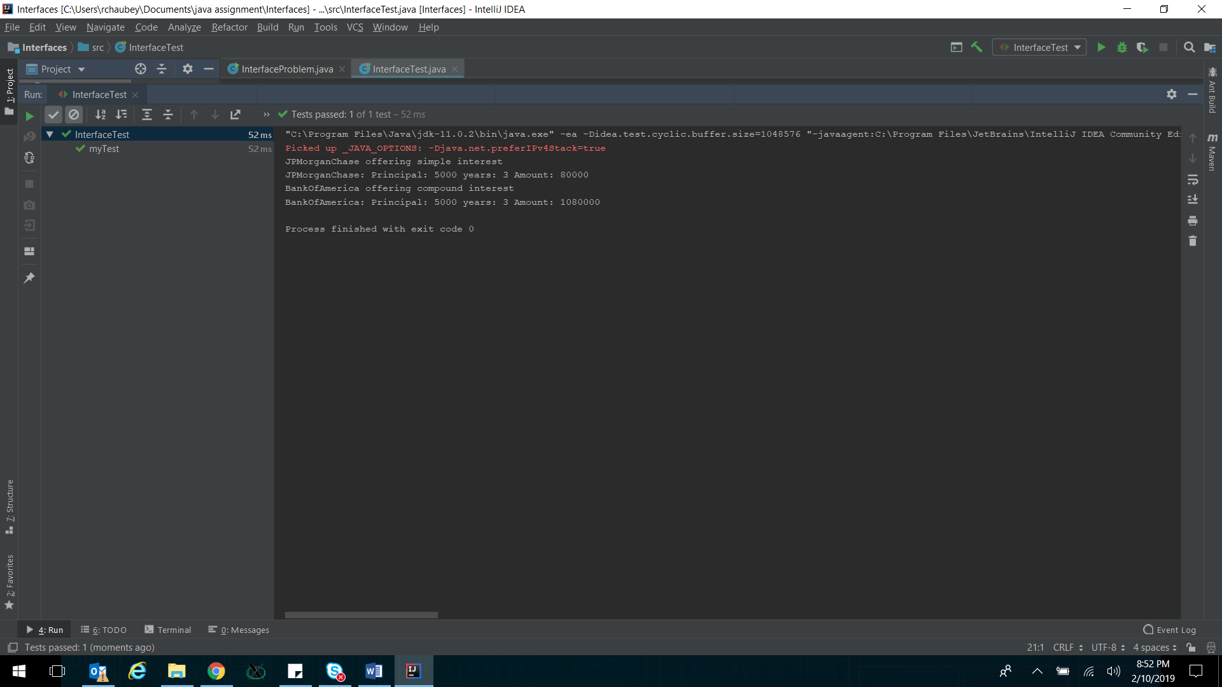

**Generics:**

**Introduction:**

Java provides capability of writing generic, type agnostic, classes and functions which can be used to create generic framework. Such a framework/class can then be instantiated for a different data types as desired by user.

**Problem**:

Using java generic class to hold and compute average of a data set of generic type. Then use this generic class method to compute for int and double data types. Use junit to verify.

**Code:**

import java.util.Arrays;  
  
class GenericData<T extends Number>{ // Generic Class which can accept list of any type extending from Number class  
 T[] list; // Generic datalist  
  
 GenericData(T[] list){ // Generic Constructor  
 this.list = list;  
 }  
  
 float genericSum(){ // Generic sum  
 float sum = 0;  
 for(T i : list){  
 sum = sum + i.floatValue();  
 }  
 return sum;  
 }  
  
 float getMean(){ // Generic mean  
 float mean;  
 mean = this.genericSum()/this.list.length;  
 return mean;  
 }  
  
 void display(){  
 System.*out*.println(Arrays.*toString*(list));  
 }  
}

import org.junit.*;  
  
public class GenericTest {  
 public class ArrayTest {  
 @Test  
 public void myTest() {  
  
 Integer Intlist[] = {12, 54, 67, 98, 65, 78};  
 GenericData<Integer> IntArray = new GenericData<>(Intlist);  
  
 Double Doublelist[] = {4.5, 6.7, 9.1, 0.1, 3.6, 8.2};  
 GenericData<Double> DoubleArray = new GenericData<>(Doublelist);  
  
 System.*out*.println("IntArray:");  
 IntArray.display();  
 System.*out*.println("Sum of IntArray: " + IntArray.genericSum());  
 System.*out*.println("Mean of IntArray: " + IntArray.getMean());  
  
 System.*out*.println("\nDoubleArray:");  
 DoubleArray.display();  
 System.*out*.println("Sum of DoubleArray: " + DoubleArray.genericSum());  
 System.*out*.println("Mean of DoubleArray: " + DoubleArray.getMean());  
  
 Assert.*assertEquals*(IntArray.genericSum(), 374.0);  
 Assert.*assertEquals*(IntArray.getMean(), 62.333332);  
 Assert.*assertEquals*(DoubleArray.genericSum(),32.2);  
 Assert.*assertEquals*(DoubleArray.getMean(), 5.366667);  
  
  
 }  
 }  
  
}

**Results:**

